# Library

Ggplot2

**library**(dplyr)

# Lesson1+2 string, vector

## String

**求一个string的长度**

nchar(a)

截取vector部分

substr(a,1,7)

分割split

names <- 'Liu/Qizhang/Singaporan'

strsplit(names,'/')

合并 paste

paste(surname, givenname, sep = '/')

paste0(a,b)

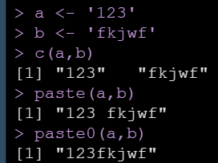

## vector

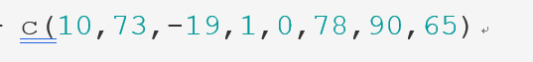

**求vector的长度**

length(a)

截取

a[c(1, 2, 5)]

替代vector

gsub('behaviour','behavior',b)

删去vector中的某一项

f <- f[-1]

等差数列 seq

seq(from=5, to=20, by=3)

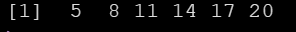

seq(5,20,length.out=10)

重复 rep

rep(1:5,3)



每个重复

rep(1:5,each=3)



**扩量合并vector 直接加或者append**

a <- c('12','bv')

b <- c('HG','JKK')

c <- c('BS','IU')

c(a,b,c)



c(a,b,'aaa')



D = append(a,'B') 这里的append并不在原来的a上面改变



**vector里截取一部分**

a <- c(10,73,-19,1,0,78,90,65)

a[length(a):(length(a)-3)] *# R里面是可以反过来取值的*

**vector命名字name**

salaries <- c(James = 5000, Janice = 4588, Tom = 2598, Joanne = 7645, Jack = 6543)

名字找vector的value

salaries[c('Tom','James')]

找名字

names(salaries[salaries > mean(salaries)])

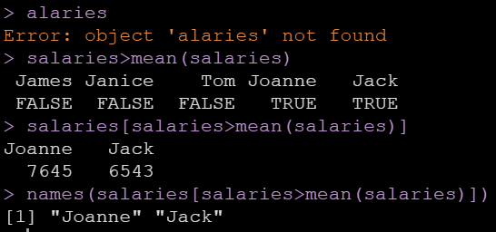

**求vector里面unique不重复的的value元素 值**

unique(PrefSchool)

建list

Jack <- list(surname = 'Wong', givenname = 'Jack', age = 35, no.children=2, is.married = T, gender = 'male')

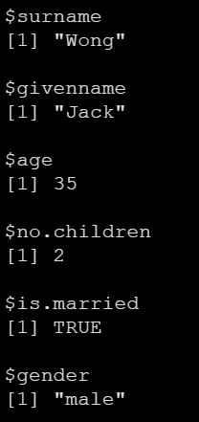

建matrix

m <- matrix(1:12, nrow=3, ncol=4)

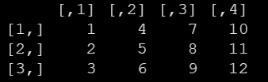

m <- matrix(1:12, 3, 4, byrow=T)

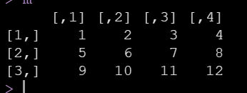

建factor

company <- c(Jame = 'Engineer', Joanne = 'Manager', Tom = 'Clerk', Joe = 'Manager', Jason = 'Engineer', Janice = 'Clerk')

company <- as.factor(company)



company <- factor(company, levels = c('Engineer','Manager','Clerk'))



# lesson3 dataframe

## 创建或者导入dataframe

给每一列的数据创建

names <- c('James','Jack','Joanne','Mike','Tom')

ages <- c(23,45,26,34,56)

salaries <- c(3000,5633,2984,9983,7356)

is.married <- c(T,F,F,T,T)

employees <- data.frame(names, ages, salaries, is.married)

给定行和列的数目，建dataframe

c <- data.frame(**matrix**(NA,529,110))

读取excel文件

library("readxl")

d <- read_excel('Study 1.xlsx')

在读取的时候就改变整个dataframe的性质，变成factor看

police0 <- read.csv('Police Use of Force.csv',stringsAsFactors = T)

## 查看dataframe特征

整体的情况 每一列的median,min,max等

summary(triers)

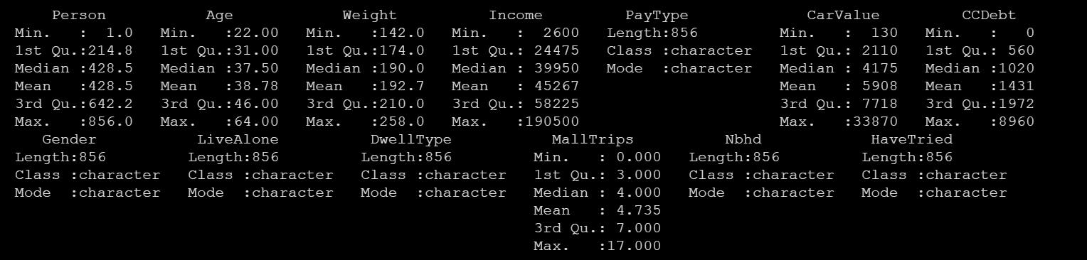

看每一列的数据类型

str(d)

求行数列数

length(employees)

nrow(employees)

dim(employees)

求某列的每个unique value出现了几次并组成新的dataframe

school.counts <- as.data.frame(table(data$PrefSchool))

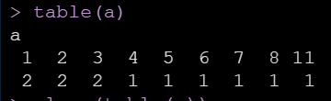

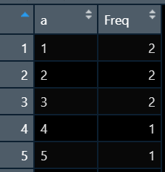 新的dataframe自动生成的那一列叫freq

并从大到小排列

school.counts <- school.counts[order(-school.counts$Freq)**,** ]

**读取导入的dataframe**

## 数据处理

**把某一列按照’：’separate按照某一指标拆分开 把一列分成多列**

library(dplyr)

library(tidyr)

ed2 <- ed1 %>% separate(GM, c('Gender','Major'), sep = ": ", remove = TRUE, convert = TRUE)

**把dataframe中所有的空格都删掉**

ed2$Gender <- trimws(ed2$Gender)*#把前后的空格删掉*

## 改变数据类型

把整个dataframe变成numeric

b <- as.data.frame(**sapply**(b, as.numeric))

把character变成logical

police$OFFICER_INJURY <- police$OFFICER_INJURY=='Yes'

把character变成时间

police$INCIDENT_DATE0 <- as.Date(police$INCIDENT_DATE, '%m/%d/%Y')

*# Y是4位,后面的'%m/%d/%Y'是原始时间string 的储存方式*

police$INCIDENT_DATE1 <- as.Date(police$INCIDENT_DATE, '%m/%d/%y')

求两个时间中间的时间

cs$duration <- as.numeric(cs$deadline - cs$launched)

## 按条件查找数据，并修改

满足某一列等于xx条件的

d$retention_1[d$retention_1 == 'False'] <- 0

d[d$retention_1 == 'True', 'retention_1'] <- 1 注意如果在中括号里面，列名要加**双引号**

**找满足条件的有多少个**

sum(police$OFFICER_YEARS_ON_FORCE < 5 & police$SUBJECT_RACE == 'Black')

**排序并且找前xx的的值**

head(companies[order(-companies$Assets...billion.),'Company'],10)

#order出来的是行的序号

*#或*

companies[order(-companies$Assets...billion.),'Company'][1:10]

*#或*

**library**(dplyr)

companies %>% filter(Continent == 'Asia' & companies$Assets...billion. > 50) %>% mutate(Profit.Margin = Profits...billion./Sales...billion.) %>% arrange(-Profit.Margin) %>% top_n(10) %>% select(Company)

#arrange也可以排序，*这个输出的结果还是一个dataframe，只不过是按照pm列从小到大排好了的，加了-就是从大到小了*

**pivot table数据透视表**

companies %>% group_by(Continent) %>% summarise(Avg.Asset = mean(Assets...billion.))

companies %>% group_by(Continent, Country) %>% summarise(Avg.Asset = mean(Assets...billion.) , number = n())

如果两个指标划分，但只输出一列的话，避免warning可以

df <- p %>% group_by(SUBJECT_RACE, TIME.SCENARIO) %>% summarise(number_of_cases=n(),.groups = 'drop')

数数

summarise(Count = n())

**把所有的列都进行同样的处理（如取平均值），绘制成数据透视表**

library(dplyr)

data.A



m <- data.A[,-1] %>% group_by(School) %>% summarise(**across(everything(),mean)**) %>% as.data.frame()

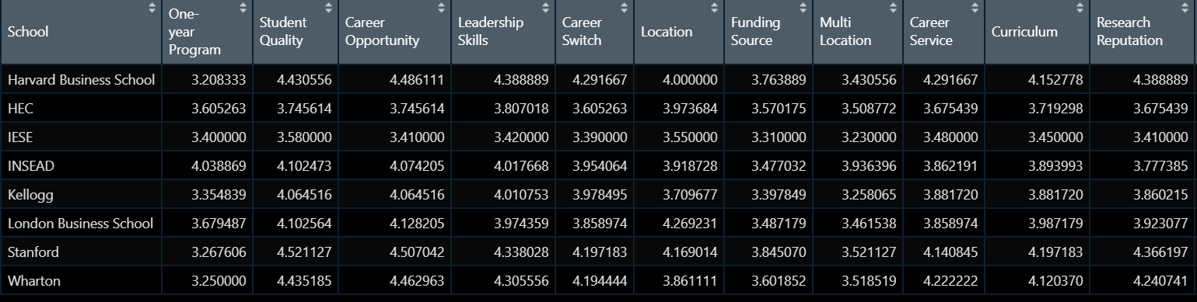

**变成可以用melt变成便于图示的**

m.sc.l <- **melt**(m.sc, id.vars='School',variable.name='Attributes')



**变成tidy/neat format/ long format**

**library**(dplyr)

**library**(tidyr)

home_l <- home_w %>% gather(Year,Rate,-Property.Type) *# 所有列除了Property.Type*

ed1 <- ed %>% gather(Year,Count,2:26)

把long format变成wide format 用到spread()

house_w2 <- home_l %>% spread(Year,Rate)

增加新列

No.Of.Childen <- c(1,2,0,2)

a <- cbind(a,No.Of.Childen)

增加新行 用rbind函数

Rose <- data.frame(names = 'Rose', position = 'Clerk', Date.Of.Join = '2021-01-02', No.Of.Childen = 0 )

a <- rbind(a, Rose)

增加新行，但有数据缺失 用bind_rows

zzx <- data.frame(names = 'zzx', position = 'student')

a <- bind_rows(a,zzx)

合并

*#1.inner join两个table中查找值相同的 行*

set1 <- merge(companies, countries, by = 'Country')

*#2.outer join 返回两个table里所有的行，有找不到的数据就会标成na*

set2 <- merge(companies, countries, by = 'Country', all = T)

*#3.left join 返回第一个table里所有的行，找不到的数据就会标成na*

set3 <- merge(companies, countries, by = 'Country', all.x = T)

*#4.right join 返回第二个table里所有的行，找不到的数据就会标成na*

set4 <- merge(companies, countries, by = 'Country', all.y = T)

# lesson4

读取tsv，每个column用tab隔开

data <- read.table("custdata.tsv",header=T,sep="\t")

读取csv，表示用comma隔开的数据

data <- read.table("Countries.csv",header=T,sep=",")

读取xml

<>叫做tag

在<>中的叫做attribute

有一对 <>和</> 在这里对中间的东西叫做text/value

**library**(XML)

data <- xmlParse("books.xml")

**l** <- xmlRoot(data)

children.lib <- xmlChildren(**l**)

找value

*#1 这个方法只能找1个value的*

xmlValue(children.lib[1])

*#2 可以找很多value的 继续用xmlChildren() + xmlToDataFrame()*

*#xmlChildren()是把node变成list*

books <- xmlChildren(children.lib[[2]]) *#[[]]变成node了*

*#xmlToDate是把list变成dataframe*

books <- xmlToDataFrame(books)

也可以直接用path得到值

data <- xmlParse("books.xml")

*#getNodeSet得到的也是list*

books <- getNodeSet(data,"/library/catalog/book[@type='HardCover']")

books <- xmlToDataFrame(books)

读取jsonlite数据

**library**(jsonlite)

url <- "https://api.data.gov.sg/v1/transport/carpark-availability"

data <- fromJSON(url)

carpark <- data$items$carpark_data[[1]]

先读几行判断类型

colclass <- c("character","character","character","character","character","character","factor","factor","factor","character","factor","factor","factor")

hospital <- read.csv("hospital-data.csv",colClasses=colclass)

# lesson5 画图

**柱状图**

**library**(ggplot2)

ggplot(data = countries, aes(x=Continent)) + geom_bar(stat='Count', fill='pink', width=0.5, color='white')

有x有y轴

country.count <- countries %>% group_by(Continent) %>% summarise(Count = n()) %>% as.data.frame()

ggplot(data = country.count, aes(x=Continent, y=Count)) + geom_bar(stat='identity', fill='pink', width=0.5, color='white')

排序

country.count <- country.count %>% arrange(Count)

country.count$Continent <- factor(country.count$Continent, level = country.count$Continent)

ggplot(data = country.count, aes(x=Continent, y=Count)) + geom_bar(stat='identity', fill='pink', width=0.5, color='white')

或者

ggplot(data=cs,aes(x=reorder(main_category,ppb),y=ppb) 把main_category按ppb排序

**涉及多个比较对象**

比较不同婚姻状况的人中，买保险的数量(涉及了两列的数据)

*#普通的bar两个会在一列上面*

ggplot(custdata) + geom_bar(aes(x=marital.stat, fill=health.ins))

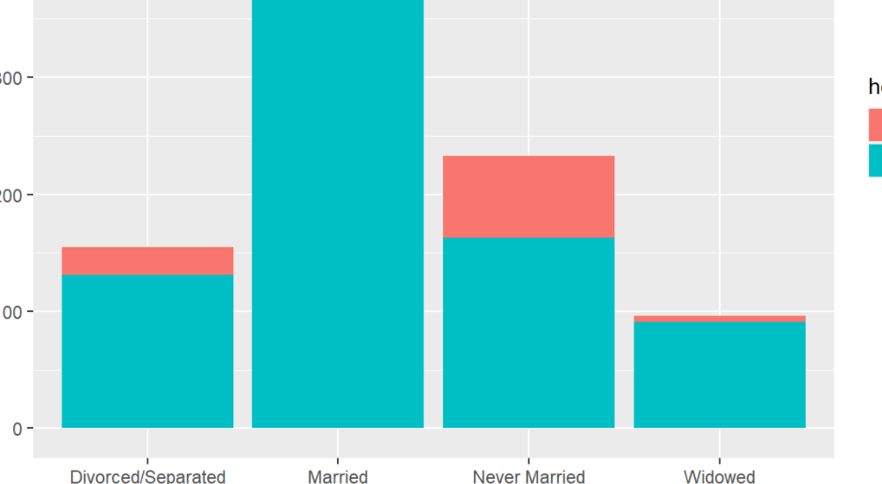

在一列上面看的不清晰，可以使用dodge变成两列

ggplot(custdata) + geom_bar(aes(x=marital.stat, fill=health.ins), position='dodge')

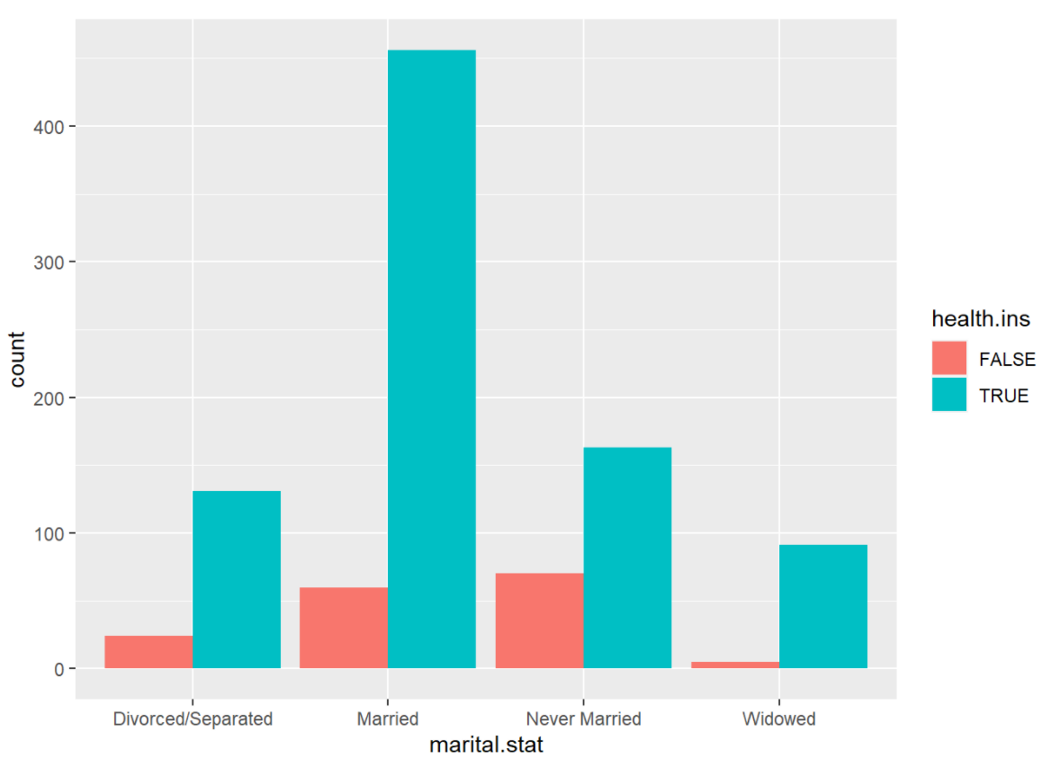

看占比fill

ggplot(custdata) + geom_bar(aes(x=marital.stat, fill=health.ins), position='fill')

*#得出的结论是：widow has the highest tendency of buying insurance product.*

用两个指标来划分，并且展示每个有多少

ggplot(data=df,aes(x=SUBJECT_RACE,y=number_of_cases,fill=TIME.SCENARIO)) + geom_bar(stat='identity', position='dodge')

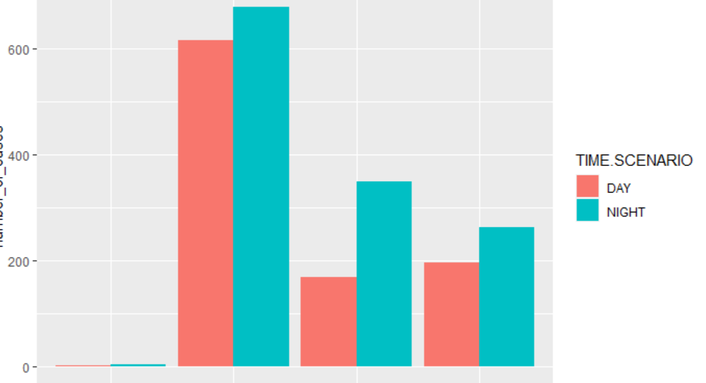

**折线图**

**library**(ggplot2)

ggplot(data = country.count, aes(x=Continent, y=Count)) + geom_line(group=1, color='black', linetype=2) *#group=1指名字是1*

**点图**

ggplot(data = country.count, aes(x=Continent, y=Count)) + geom_point(size=4, color='black', shape=19) + xlab(’’) + ylab(’’)

**tile chart 当多个指标（不同的学校..）有多个变量的时候，比折线图更加清楚**

ggplot(m.sc.l, aes(x=Attributes, y=School)) + geom_tile(aes(fill=value)) + theme(axis.text.x=element_text(angle=90)) + scale_fill_gradient(low='white',high='blue')

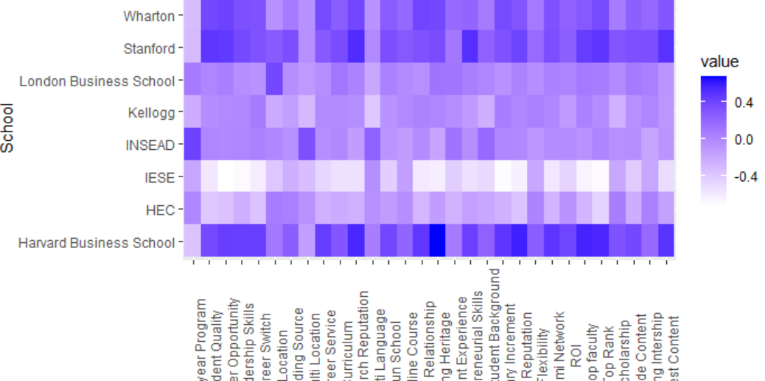

**对比折线图**

ggplot(data=m.sc.l,aes(x=Attributes, y=value, color=School, group=School)) + geom_line() + theme(axis.text.x = element_text(angle=90))

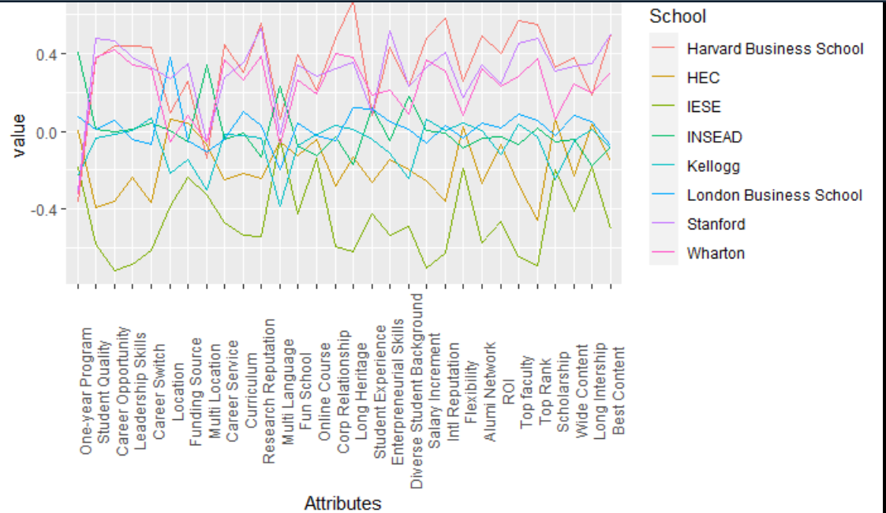

**几种图layer重合**

ggplot(data = country.count, aes(x=Continent, y=Count)) + geom_point(size=4, color='blue', shape=25) + geom_line(group=1, color='pink', linetype=4) *#哪个后写的哪个在上面*

不同数据集source里的

ggplot() + geom_bar(data=countries,aes(x=Continent),fill='pink') + geom_point(data=country.count, aes(x=Continent,y=Count), size=2, color='blue', shape=25) + geom_line(data=country.count, aes(x=Continent,y=Count), group=1, color='green', linetype=4)

根据某一数据上color

ggplot(countries, aes(x=GDP_Per_Capita, y=Life_Expectancy,size=Population, color=Continent)) + geom_point()

probability/density of each data

ggplot(countries,aes(x=GDP_Per_Capita)) + geom_density()

把lognormal变成normal

ggplot(countries,aes(x=log10(GDP_Per_Capita))) + geom_density()

就可以把none liner relationship不好，所以要通过log变成liner relationship

g1 <- ggplot(countries, aes(x=GDP_Per_Capita, y=Life_Expectancy, size=Population, color=Continent)) + geom_point() + scale_x_log10()

*#譬如得到y=10.4*log10(x)+25*

*#log10(x)增加1，y增加10.4；也就是x增加10倍，y增加10.4。 x increases by 10 times, y increases by 10.4。*

Scale the color这个是针对前面的color=Continent

g1 + scale_color_manual(values=c('red','green','yellow','black','blue','orange'))

polar system

g2 <- ggplot(data = countries, aes(x=Continent, fill = Continent)) + geom_bar(width=0.5)

g2 + coord_polar()

faceting 分层

g1 + scale_color_manual(values=c('red','green','yellow','black','blue','orange')) + facet_wrap(~Continent)*#也可以ncol=1*

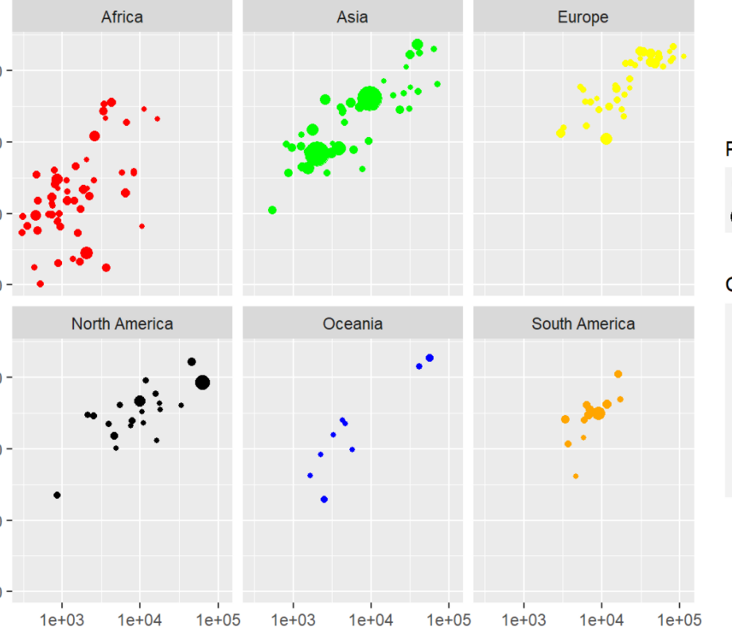

横着放一行

g1 + scale_color_manual(values = c('red','green','yellow','black','blue','orange')) + facet_wrap(~Continent, nrow=1)

plotly package可以做interactive one

**library**(plotly)

ggplotly(g1)

gganimation package动画

**library**(gganimate)

**library**(gapminder) *#包含很多国家数据的数据库*

g4 <- ggplot(gapminder, aes(x=gdpPercap, y=lifeExp, size=pop, color=continent)) + geom_point() + scale_x_log10() + theme_bw()

g <- g4 + transition_time(year) + labs(title='Year: {frame_time}')

animate(g,renderer=gifski_renderer())

**做animation**

g1 <- ggplot(vax_countries, aes(x = GDP, y = total_vaccinations_log10)) +

geom_point() +

scale_x_log10() + #像这里有时候数字太大了，可以log10一下，同时y也可以

xlab("G.D.P.") +

ylab("# of Total Vaccinations")

g1 <- g1 + transition_time(date) + labs(title = "{frame_time}")

animate(g1, renderer = gifski_renderer())

jitter 防止重合

ggplot(custdata,aes(x=marital.stat,y=age)) + geom_point() + geom_jitter(position=position_jitter(0.2)) + ylim(c(0,100))

boxplot

ggplot(custdata,aes(x=marital.stat,y=age,color=health.ins)) + geom_boxplot(color='black') + geom_jitter(position = position_jitter(0.2)) + ylim(c(0,100))

*#boxplot的颜色按照前面ggplot的color决定*

ggplot(custdata,aes(x=marital.stat,y=age,color=health.ins)) + geom_boxplot() + geom_jitter(position = position_jitter(0.1)) + ylim(c(0,100))

# Lesson6

改大标题

标签 labs(title=, subtitle=)

改变x、y轴标题

+xlab('Launched date')

+ylab(‘’)

改标题的格式

+theme(axis.title.x = element_text(size=12, color='blue',face='italic')

改xy轴指标的格式竖着

+ theme(axis.text.x = element_text(angle=90))

改指标的名称**scale_x_discrete(label=)**

*#因为这里的value要么是true，要么是false*

hasinsurance <- **function**(x)

{

**return**(ifelse(x,'Has insurance','No insurance'))

}

ggplot(custdata,aes(x=health.ins,fill=health.ins)) + geom_bar(width=0.3) + **scale_x_discrete(label=**hasinsurance)

改背景

+theme(panel.background=element_rect(fill='lightgrey'))

Ggmap

有不同的map type： satellite, hybrid, toner, water, color, terrain-background, toner-lite

**library**(ggmap)

SG <- get_map('Singapore',zoom=11, maptype = 'satellite')

ggmap(SG)

把图和已有的数据合并起来

ggmap(SG) + geom_point(data=pizzahut, aes(x=Lon, y=Lat), size=3, color='red')

调整透明度来显现density

sfmap <- get_map('San Francisoo', zoom=12, maptype='toner-lite')

ggmap(sfmap) + geom_point(data=sf, aes(x=lon,y=lat), alpha=0.05)

**heatmap来展现 stat_density2d(fill=..density..)**

**library**(viridis)*#这是一个调色的安装包*

ggmap(sfmap) + stat_density2d(data=sf, aes(x=lon,y=lat, fill=..density..),geom='tile',contour = F,alpha=0.5) + scale_fill_viridis(option='inferno')

# contour等高线

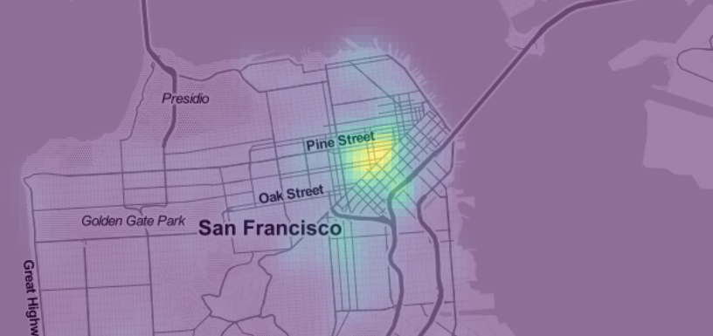

或者用leaflet

**library**(leaflet)

**library**(tidyverse)

**library**(leaflet.extras)

m <- leaflet(quakes) %>% addProviderTiles(providers$CartoDB.DarkMatter) %>% **addWebGLHeatmap**(lng=~long,lat=~lat,size=60000)*#each event colored has a physical radius of 6000 metres*



based on magnitudes

leaflet(quakes) %>% addProviderTiles(providers$CartoDB.DarkMatter) %>% addWebGLHeatmap(lng=~long,lat=~lat,**intensity=~mag**,size=10000)

m <- leaflet(p) %>% addProviderTiles(providers$CartoDB.DarkMatter) %>% addWebGLHeatmap(lng=~LOCATION_LONGITUDE,lat=~LOCATION_LATITUDE,size=600) %>% setView(lat = 32.78220, lng = -96.79746,zoom = 11)

**边界borderborder polygon coloring 按照数字划分颜色**

先找一个dataframe，里面的column是name和polygon；

再找一个dataframe，里面的column是name和population。

把d2和d1用name合并起来

**library**(raster)

**library**(rgdal)

**library**(XML)

*#gadm是一个地图的database*

SG <- getData('GADM', country='SG', level=1)

*#看看SG里面包含了什么 用@*

SG@data

*#可以用于查看是怎么划分区域的*

SG$NAME_1

*#直接加了一列*

SG$pop <- c(1928932,3874774,766666,2883434,7376362)

spplot(SG,'pop')

用merge把两个dataframe中的数量和地图合并起来

population <- data.frame(Region=c("Central","East","North","North-East","West"),value=c(23435,43451,34254,56432,78131))

SG@data <- merge([SG@data,population,by.x='NAME_1',by.y='Region](mailto:SG@data,population,by.x='NAME_1',by.y='Region)')

spplot(SG,'value')

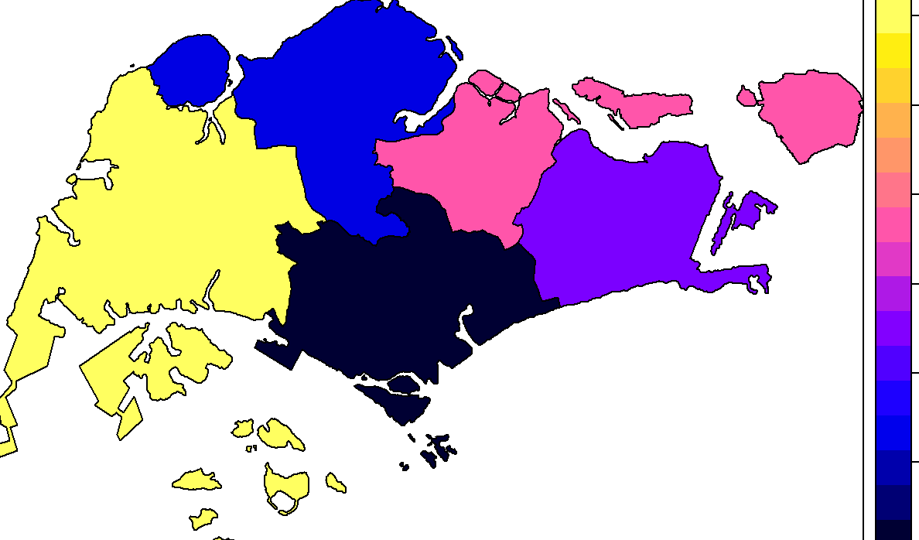

用leaflet

**library**(raster)

**library**(leaflet)

*#前面和spplot的操作一样*

d1 <- data.frame(Region=c('Central','East','North','North-East','West'),Value=c(3,4,1,7,10))

SG <- getData('GADM', country='SG', level=1)

SG@data <- merge(SG@data,d1,by.x='NAME_1',by.y='Region')

*#这可以搞个标签*

popup <- paste0("<strong>Name: </strong>",SG$NAME_1)

*#创建一个调色板palette 按照降水量来显示颜色 降水量越大 颜色越深*

pal <- colorNumeric(palette='Blues', *#Blues一系列的蓝色*

domain=SG$Value) *#通过给定的paltte，将数据映射到颜色，数字越大颜色越深*

m <- leaflet() %>% addTiles() %>% addPolygons(data=SG,

weight=2,*#描边宽度*

stroke = TRUE,

smoothFactor = 0.1, *#缩放简化折线的程度(越大性能好清晰度差)*

fillOpacity = 0.8, *#填充不透明度*

color = ~pal(Value),

popup=popup)

随便给的颜色

factpal <- colorFactor(topo.colors(5),SG$Value)

m <- leaflet() %>% addTiles() %>% **addPolygons**(data=SG,weight=2,stroke=F,smoothFactor = 0.2,fillOpacity = 0.8,color=~factpal(Value),popup = popup)

**把国家命名标准化，用countrycode这个包。一个是genc3c，一个是iso code**

library(countrycode)

country$cd <- countrycode(country$Country, origin = "country.name", destination = "genc3c")

countries$iso_code <- countrycode(countries$Country, origin = 'country.name', destination = 'iso3c')

**把小数舍去round**

data$cfp <- round(data$Confirmed / data$Population * 100000)

**转为浮点数，便于相乘**

v$Population <- as.double(v$Population)

**加一条线**

a <- mean(cs$ppb)

ggplot(data=cs,aes(x=reorder(main_category,ppb),y=ppb)) + geom_bar(stat = 'summary', fun.y = 'mean') + theme(axis.text.x=element_text(angle=90)) + **geom_hline(yintercept=a,colour = 'blue', size = 0.7)** + labs(y='Average amount pledged per backer', x='Category')

**控制y轴的范围**

+ coord_cartesian(ylim = c(0,60000))

**Aids the eye in seeing patterns in the presence of overplotting帮助眼睛在过度绘制的情况下看到图案**

ggplot(data=cs,aes(x=duration, y=usd_pledged_real)) + geom_point(alpha=0.1) + geom_smooth(color='blue') + scale_y_log10()

**把date变成年月的形式**

format(as.Date(df1$launched),"%Y-%m")

再加上每个月的第一天

df1$launched <- as.Date(paste0(**format(**as.Date(df1$launched), "%Y-%m"**)**,'-01'))

**变成时间的形式**

library(data.table)

p <- p %>% mutate(intimenew = as.ITime(as.POSIXct(INCIDENT_TIME, format = '%I:%M:%S %p')))

a <- as.ITime(as.POSIXct('6:00 AM', format = '%I:%M %p'))

b <- as.ITime(as.POSIXct('7:00 PM', format = '%I:%M %p'))

**按x轴的值对y轴上的变量进行计算**

+geom_bar(stat = 'summary', fun.y = 'mean')

+geom_line(aes(x=launched,y=usd_pledged_real),stat='summary',fun.y='median')

**上色color**

色板colormap

library(RColorBrewer)

cols <- colorRampPalette(brewer.pal(9, 'YlOrRd'))(length(countries$GDP_Per_Capita))

**删除dataframe中的某列或者保留某列**

p <- subset(p, **select** = -INCIDENT_TIME_new)

**d$residual <- NULL** 这个就是直接把某一列删除

**也可以通过select提取dataframe中的几列**

attributes <- c('Multi Location','Student Experience','Flexibility','Diverse Student Background','Multi Language','Fun School','Long Heritage','Research Reputation')

**筛选不符合条件的某列**

cs <- cs[!(cs$backers==0 & cs$state=='successful'),]

**删除某行**

ed <- ed[c(-1,-17),]

#或者

gdp_map <- subset(gdp_map, continent != "Antarctica")

**删除na的行**

na.omit(your.data.frame)

‘

**删除某个变量**

**rm(a)**

**combined bar and line with legend堆积图**

ggplot(df1,aes(x = time))+

geom_bar(aes(y = number,fill = is_canceled),stat="identity") +

geom_line(aes(y=adr*50, color=''),stat="identity", group = 1) +

geom_point(aes(y=adr*50)) +

scale_y_continuous("Number of records", sec.axis = sec_axis(~ . /50, name = "Price")) +

scale_color_manual('', labels = 'Price', values = 'black') +

xlab('Arrival time') +

labs(title='Distribution of records and price over the time')

**Leaflet**

一个

**library**(leaflet)

library(tidyverse)

my_map <- leaflet() %>% addTiles () %>% addMarkers(lat = 1.25011 , lng = 103.83093 , popup ="Sentosa Island")

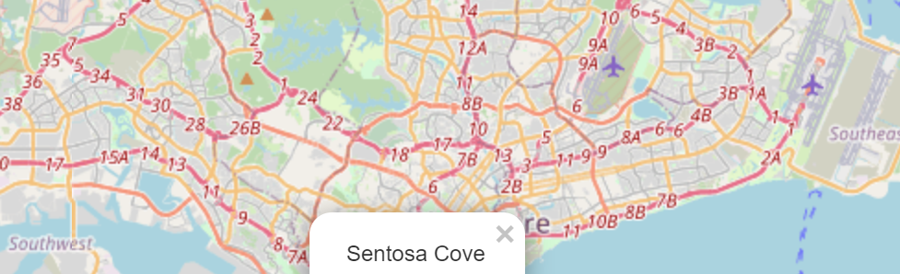

多个

df <- data.frame(lat = c(1.25011,1.28544, 1.318707, 1.282375, 1.4043, 1.4022, 1.4029 , 1.2868 , 1.3332, 1.2893 ) , long =c(103.83093 ,103.859590, 103.706442 , 103.864273 , 103.7930 , 103.7881 , 103.7917, 103.8545, 103.7362 , 103.8631) , popup = c("Sentosa Island", "Marina Bay Sands " , "Jurong Bird Park","Gardens By the Bay", "Singapore Zoo" , "Night Safari", "River Safari", "Merlion Park","Science Center", "Singapore Flyer") )

my_map <- leaflet() %>% addTiles() %>% addMarkers(data = df , lng = ~long , lat = ~lat , popup = df$popup)

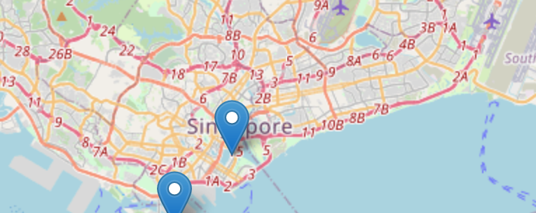

**cluster the attractions 圈出来一块区域**

my_map %>% leaflet() %>% addTiles() %>% addCircleMarkers(data = df , lng = ~long , lat = ~lat , radius = 5 , clusterOptions = markerClusterOptions())



We can make the map more expressive by adding Icons

sgIcon <- leaflet::makeIcon(iconUrl = "http://img.freeflagicons.com/thumb/speech_bubble_icon/singapore/singapore_640.png", iconWidth = 41*225/240 , iconHeight = 41, iconAnchorX = 31*215/230/2, iconAnchorY = 16 )

my_map <- leaflet() %>% addTiles() %>% addMarkers(data = df , lng = ~long , lat = ~lat , popup = df$popup , icon = sgIcon)

**做一个能选择的区域和地图模式的interactive的map**

pizzahut.location <- read.csv('PizzaHut.csv')

*#先划分4个层*

region.list <- c('North','East','Central','West')

*#每个region给不同的颜色*

colorFactors <- colorFactor(c('red','green','blue','brown'),domain=pizzahut.location$Region)

m <- leaflet() %>% addTiles()

*#把所有数据分为4层，对应上面的region，每一层建成一个dataframe*

**for**(i **in** 1:4)

{

pizzahut.region <- pizzahut.location[pizzahut.location$Region == region.list[i],]

m <- addCircleMarkers(m,

lng=pizzahut.region$Lon,

lat=pizzahut.region$Lat,

popup = pizzahut.region$Address,

radius=10,

stroke = F,

fillOpacity=1,

color = colorFactors(pizzahut.region$Region),

group = region.list[i])

}

*#在前面不同区域图层的基础上增加不同map的形式*

*#http://leaflet-extras.github.io/leaflet-providers/preview/index.html*

*#参考这个网站里面有不同的provider*

m <- addTiles(m,group='Default')

m <- addProviderTiles(m,'Esri.WorldImagery',group='Esri')

m <- addProviderTiles(m,'Stamen.Toner',group='Toner')

m <- addProviderTiles(m,'Stamen.TonerLite',group='Toner Lite')

m <- addLayersControl(m,

baseGroups = c('Default','Esri','Toner','Toner Lite'),*#这个是每次只能出现一个*

overlayGroups = region.list)*#overlaygroups是可以共存的 coexist的group*



**随机生成一组序列**

rnorm(mean=100 , sd=1,200)

sd标准差 standard deviation

方差 variance

**判断在不在一组vector里面**

r <- c('White', 'Black', 'Hispanic','Asian')

p <- p %>% filter(SUBJECT_RACE %in% r)

**数用comma隔开的数据有多少个**

p$cuof <- count.fields(textConnection(p$UOF_NUMBER), sep = ",")

**算用comma隔开的element的总value是多少**

p$N_new<- sapply(strsplit(p$NUMBER_EC_CYCLES, ", "), function(x) sum(as.numeric(x)))

**character转化成货币形式**

sales <- c(1736134, 10034,1003948,209445,98878.76,398454,777734.12,1039489.34,293894,9834,9384754.65)

s1 <- paste0("$", formatC(as.numeric(sales), format="f", big.mark=","))

**01，02………**

number <- formatC(1:length(sales),width = 2, flag = 0)

**strsplit的使用**

s3

[1] "Athens, Paris, St. Louis, London, Stockholm, Berlin , Antwerp, Paris, Amsterdam, Los Angeles, Berlin, Tokyo , London , London, Helsinki, Melbourne, Rome, Tokyo, Mexico City, Munich, Montreal, Moscow, Los Angeles, Seoul, Barcelona, Atlanta, Sydney, Athens, Beijing, London, Rio de Janeiro, Tokyo"

strsplit(s3,', ')变成一个列表

[[1]]

[1] "Athens" "Paris" "St. Louis" "London" "Stockholm"

[6] "Berlin " "Antwerp" "Paris" "Amsterdam" "Los Angeles"

[11] "Berlin" "Tokyo " "London " "London" "Helsinki"

[16] "Melbourne" "Rome" "Tokyo" "Mexico City" "Munich"

[21] "Montreal" "Moscow" "Los Angeles" "Seoul" "Barcelona"

[26] "Atlanta" "Sydney" "Athens" "Beijing" "London"

[31] "Rio de Janeiro" "Tokyo"

**删除所有小括号和中括号**

*# remove text inside parenthesis*

cities <- gsub(" \\(.*?\\)", "", countries)

*# remove text inside square brackets*

cities_cleaned <- gsub(" \\[.*?\\]", "", cities)

**改多列名**

colnames(ed) <- c('GM',1993:2017)

改一列名

names(df)[names(df) == 'old.var.name'] <- 'new.var.name'

**把dataframe中有，的数字变成数字格式**

ed2$Count <- gsub(',','',ed2$Count)

ed2$Count <- trimws(ed2$Count)

a[is.na(a)] <- 0 *#把na都变成0*

ed2$Count <- as.numeric(ed2$Count)

**最大的，返回名称**

d3 <- d2 %>% group_by(Year) %>% summarise(number=sum(Count))

**求vector中每个element的长度用nchar**

nchar(d6$year)==2])

**再ggplot上面搞个标签**

library(ggrepel)

ggplot(df2,aes(x=mean_pledge,y=success_rate,color=main_category,size=median_goal))+

geom_point()+

**geom_label_repel**(aes(label = main_category), size=2.5,box.padding=0.3)+

xlab('Average Amount Pledged per Backer (USD) ') +

ylab('Success Rate')

# lesson7

**关于full loop**

for(i in 1:10)

{

word <- paste('Word:',i)

print(word)

}

**function和simulation**

PlayOneGame <- function(iter)

{

doors <- c('Door1','Door2','Door3')

#step1: Host decide what door to put the prize

prize.door <- sample(doors,1)

#step2: Player choose the door

chosen.door <- sample(doors,1)

#step3: Host open a door

remain.doors <- doors[doors != prize.door & doors != chosen.door]

open.door <- sample(remain.doors,1)

#step4: swap to another door

swap.door <- doors[doors != open.door & doors != chosen.door]

#Return T if swap door wins the price, F otherwise

return(prize.door == swap.door)

}

n <- 10000

totalWins <- 0

for (i in 1:n)

{

totalWins <- totalWins + PlayOneGame(i)

}

prob.winning.by.swapping <- totalWins / n

prob.winning.by.swapping

**对xxxx重复使用同样的公式，生成的是一个vector**

PlayOneGame是公式

sapply(1:n,PlayOneGame)

# lesson8 线性回归 linear regression

### linear regression model

model <- **lm**(Height ~ Foot, data=f) 这一步是run the model

summary(model) 这一步是看结果

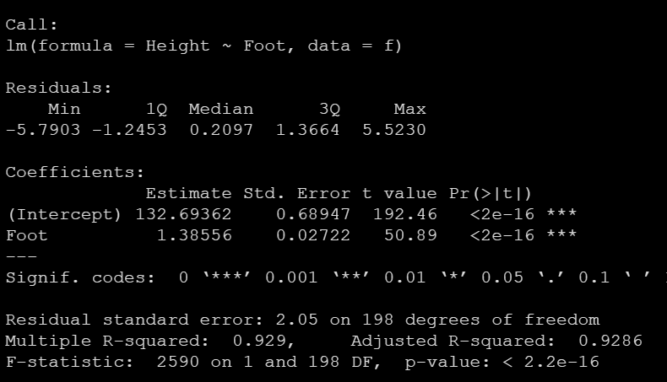

#residuals/error残差，是difference between the predicted value and actual value

#coefficients指的是H = 1.38556*F+132.69362 one unit increase in foot, height of person increases by 1.38556 cm.

# p value，the smaller is, more statistically, more significant

# ***behind is a visual of significance，0.05 is the normal index

# multiple r-squared value，always below 1，92.9% of the variance in the height can be contributed to (explained by) foot， if we use foot to predict height, 92.9% will be correct，50% is very good

**预测 predict（），用算出来的model来推测新的值（注意预测的data要有因变量的那一列）**

f$Predicted.Height <- predict(model, f)

f$Residual <- f$Predicted.Height - f$Height 可以看一下residual是多少

head(f)

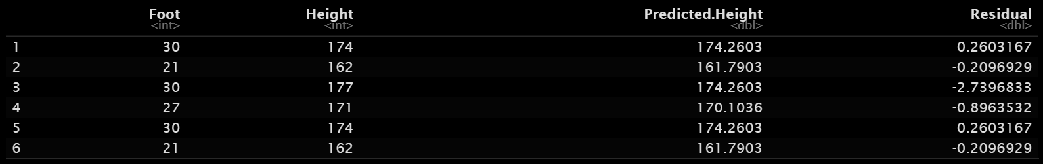

**Assumptions of linear regression**

y = ax + b

1.linearity

dependable variable和 independent variable 是线性的关系

2.normality of error

residual must follow normal distribution, their mean=0

3.no auto-correlation(independence of errors)随机误差之间没有**自相关性** 这个需要自己判断linear regression 不用来解决 time-period problems,因为前一年和这一年的变量两两之间会有correlation，而在多元回归中的**多重共线性**才是指自变量和自变量间有相关性

4.homoscedasticity(equal variance)同方差性

是指**随机误差项**在解释变量条件下具有不变的方差有不变的**方差**。计量经济学中， 一组随机变量具备同方差即指线性回归的最小二乘法（OLS, Ordinary Least Squares）的**残差residual/error**服从均值为0，方差为σ^2的正态分布，即其干扰项必须服从随机分布

random errorterm随机误差项/随机扰动项/干扰项是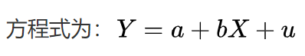中的u，随机误差项一般包括：1)模型中省略的对被解释变量不重要的影响因素 (解释变量)；2)解释变量和被解释变量的观测误差；3)经济系统中无法控制、不易度量的随机因素

**验证validate以上的假设**

Plot(model)

1.是否是linearity，应该是一条水平线：

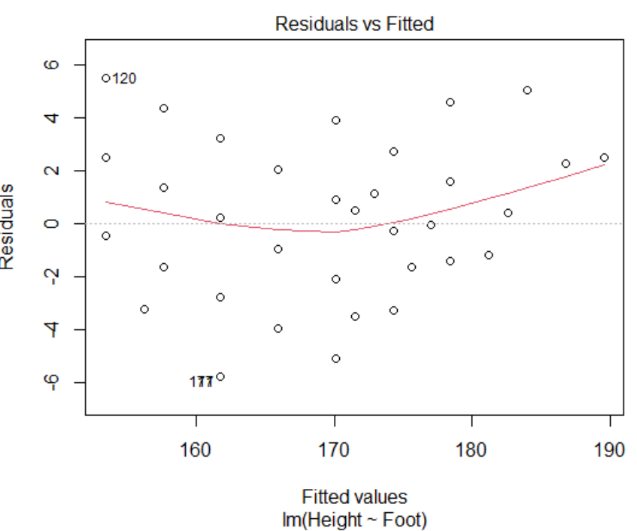

**处理方法：加平方项**

model <- lm(Height ~ Foot, data=f)

summary(model)

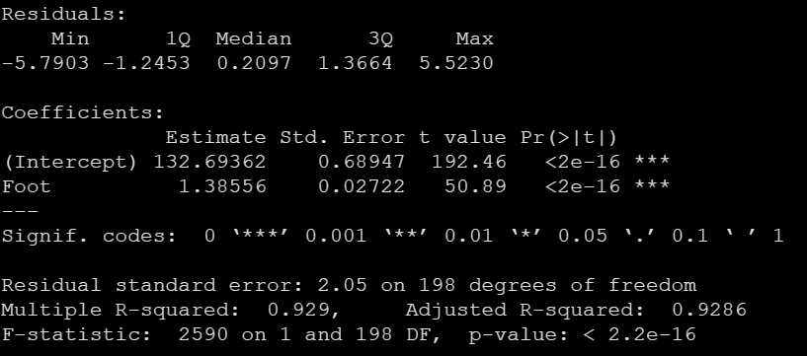

model2 <- lm(Height ~ Foot + **I(Foot^2)**,data=f) #加了square turn

summary(model2)

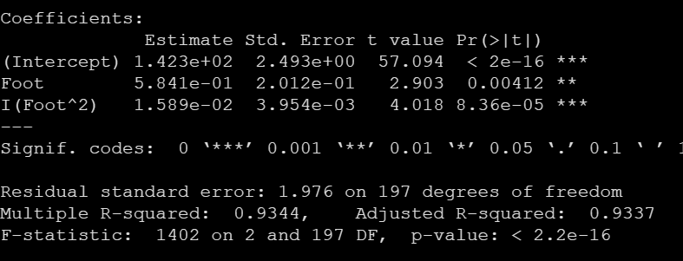

plot(model2)

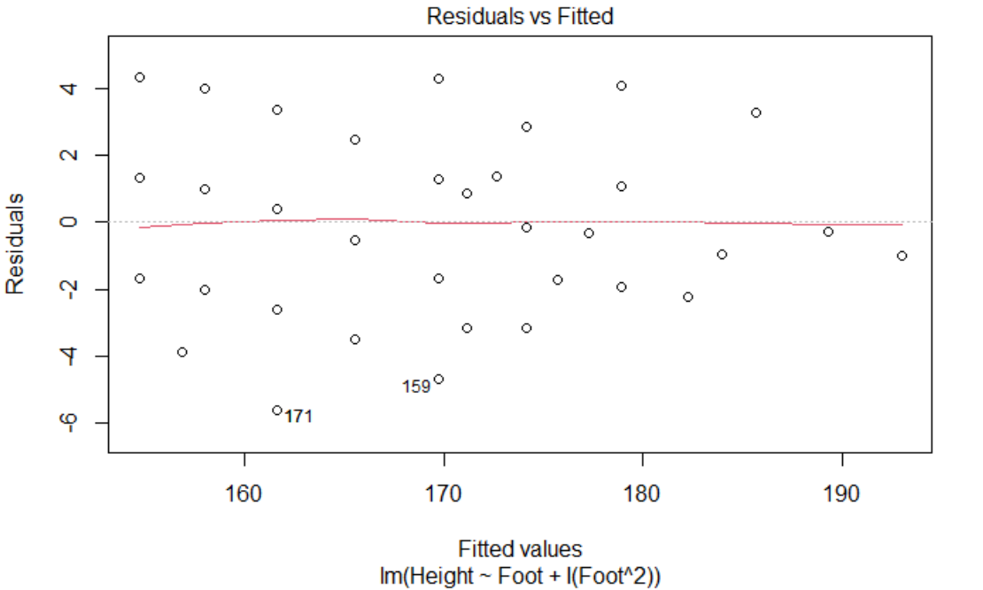

处理之后发现residual曲线变平了

但事实上这个模型并不好，因为只提高了一点点r^2，但是非常难以解释。

2.说明normality 看residual是不是normal distribution 应该都在一条线上：

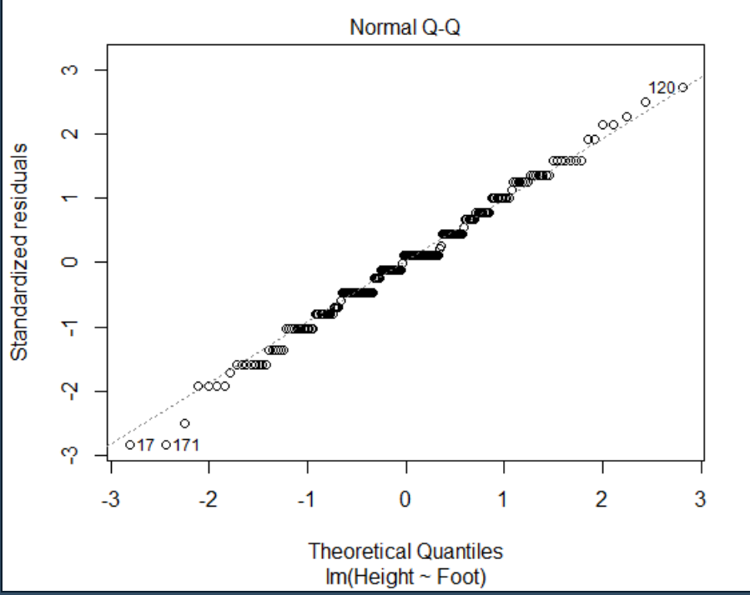

3.说明equal variance homoscedasticity 也应该是一条水平直线 被标注数字的两个点是outliers，表示他们的residual是abnormal的，他们的residual太大了，而其他的残差很小。所以他们是outliers

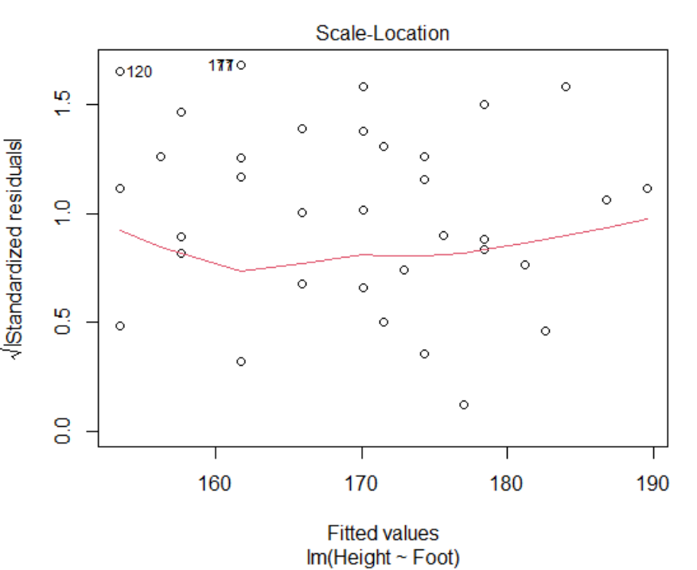

4.被标注数字的点是high leverage。如果他的残差不大，那么它加进来对整个回归的model没有大影响，但一旦它很反常abnormal，他就会对整个model有很大的影响，就完了，他就是既是high leverage，也是outlier了

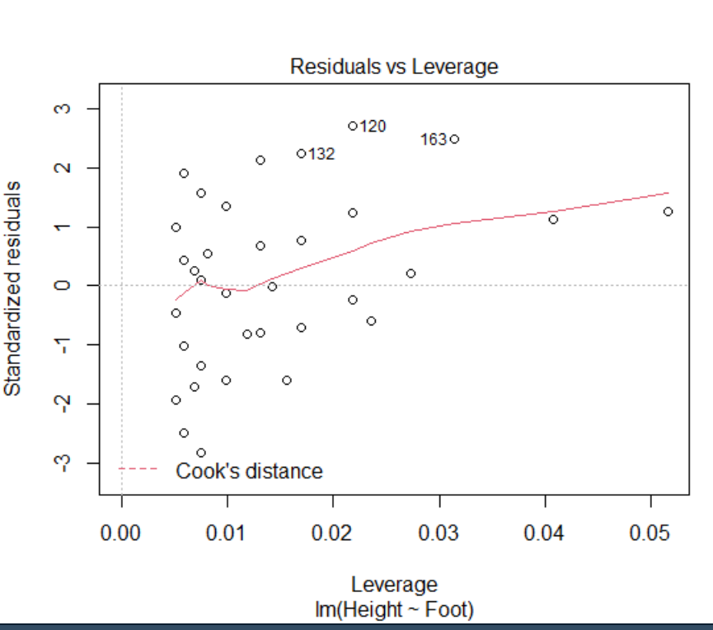

#解释一下high leverage是什么意思

先用线性回归画smooth图

library(ggplot2)

ggplot(data=f,aes(x=Foot, y=Height)) + geom_point() + geom_smooth(method='lm') + theme_bw()

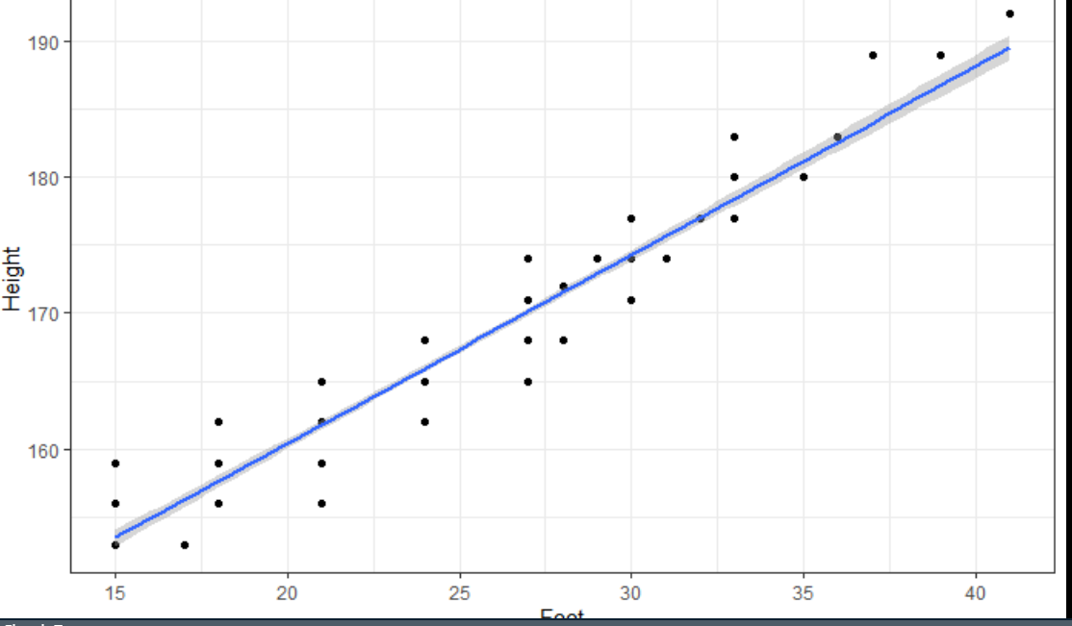

接下来把姚明的数据加进来

yao <- data.frame(Foot=68, Height=229)

f1 <- rbind(f,yao)

ggplot(data=f1,aes(x=Foot, y=Height)) + geom_point() + geom_smooth(method='lm') + theme_bw()

lm图很可能就变成这样了

只有在第二条线的情况下才是既是high leverage又是outlier

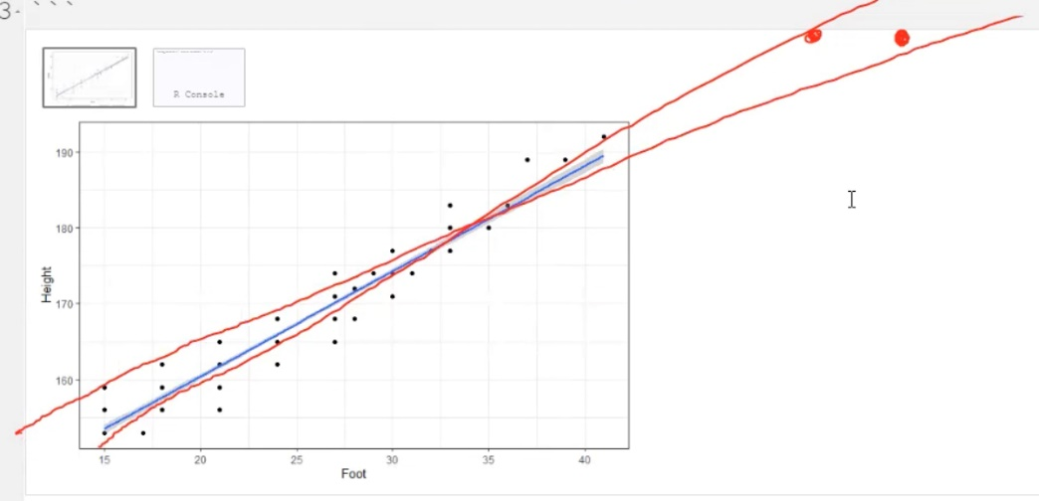

Outlier和high leverage的区别

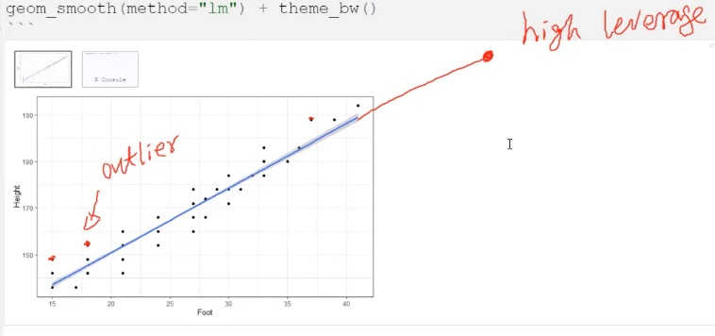

**用quote distance去判断到底是不是outlier**

yao <- data.frame(Foot=68, Height=229)

f1 <- rbind(f,yao)

model1 <- lm(Height ~ Foot,data=f1)

summary(model1)

plot(model1)

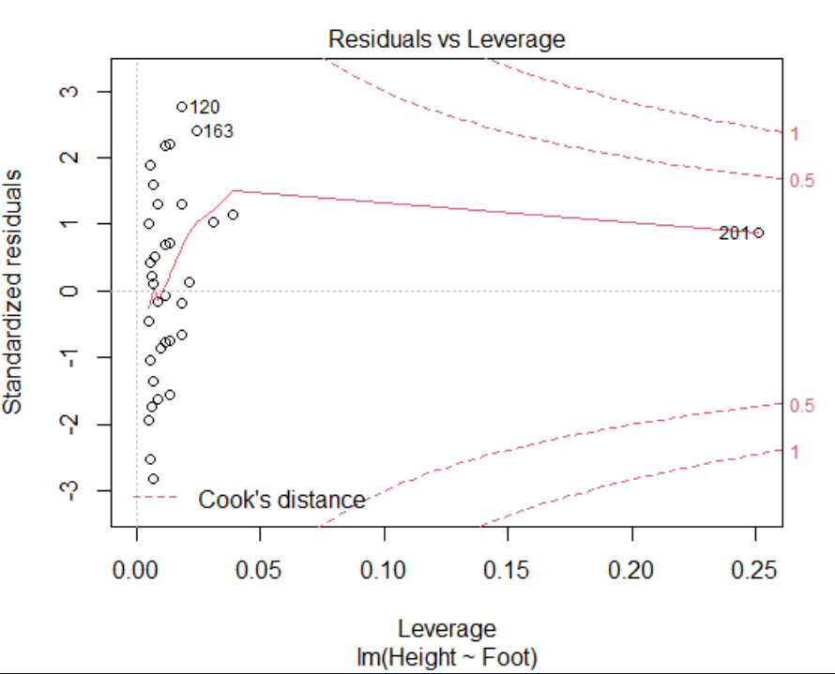

Cook’s distance是threshold

在1的外面是super high leverage point

在0.5和1中是high level point，需要注意

在0.5内是acceptable point

可以看到在这个图里201是ok的

但如果改变一下数据

yao <- data.frame(Foot=62, Height=229)

f1 <- rbind(f,yao)

model1 <- lm(Height ~ Foot,data=f1)

summary(model1)

plot(model1)

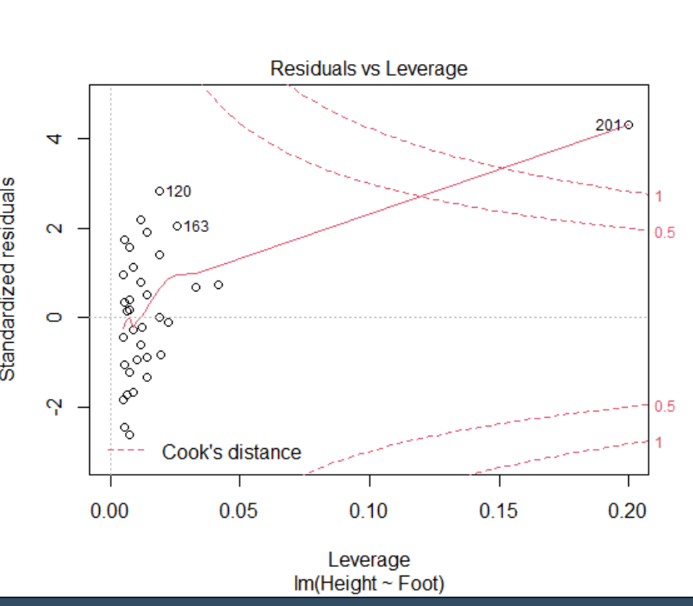

就在1外面了，这个就需要注意，201指的是第201个。（行数是201）

**可能会遇到的情况 standardized residual标准化残差**

1.有outliers，有些变量的residual不是normal distribution

要用log去transform the data

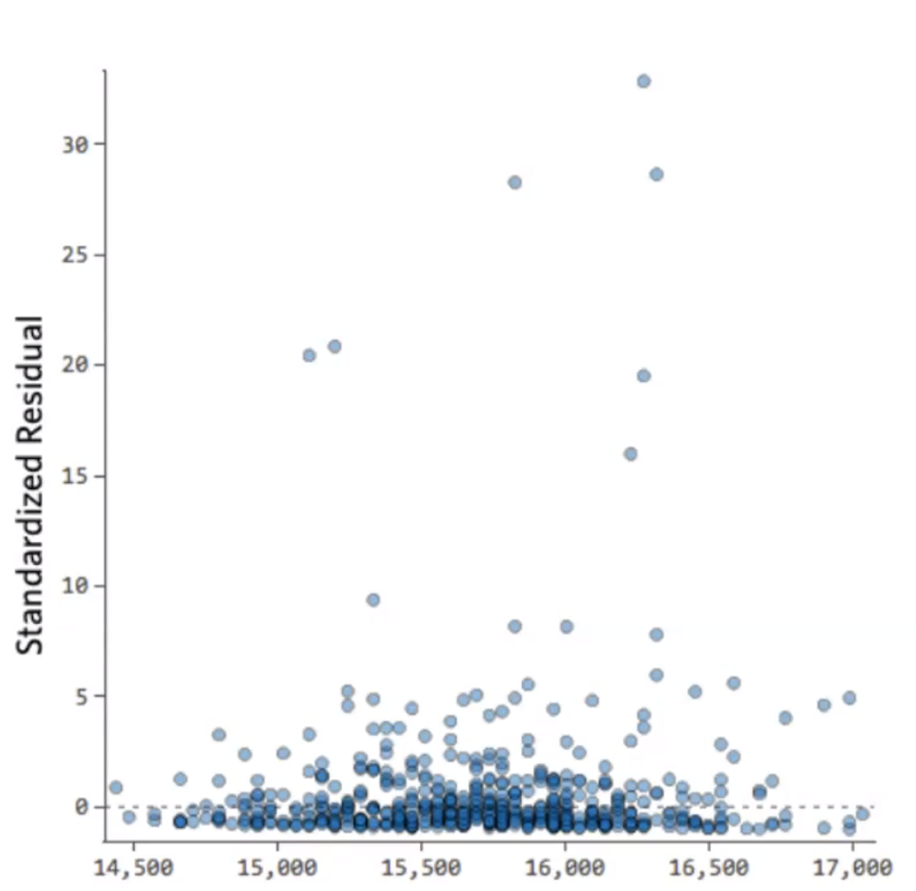

2. 没有homoscedasticity(equal variance)同方差性

当x很小的时候error小，而当x变大的时候，error就越来越大

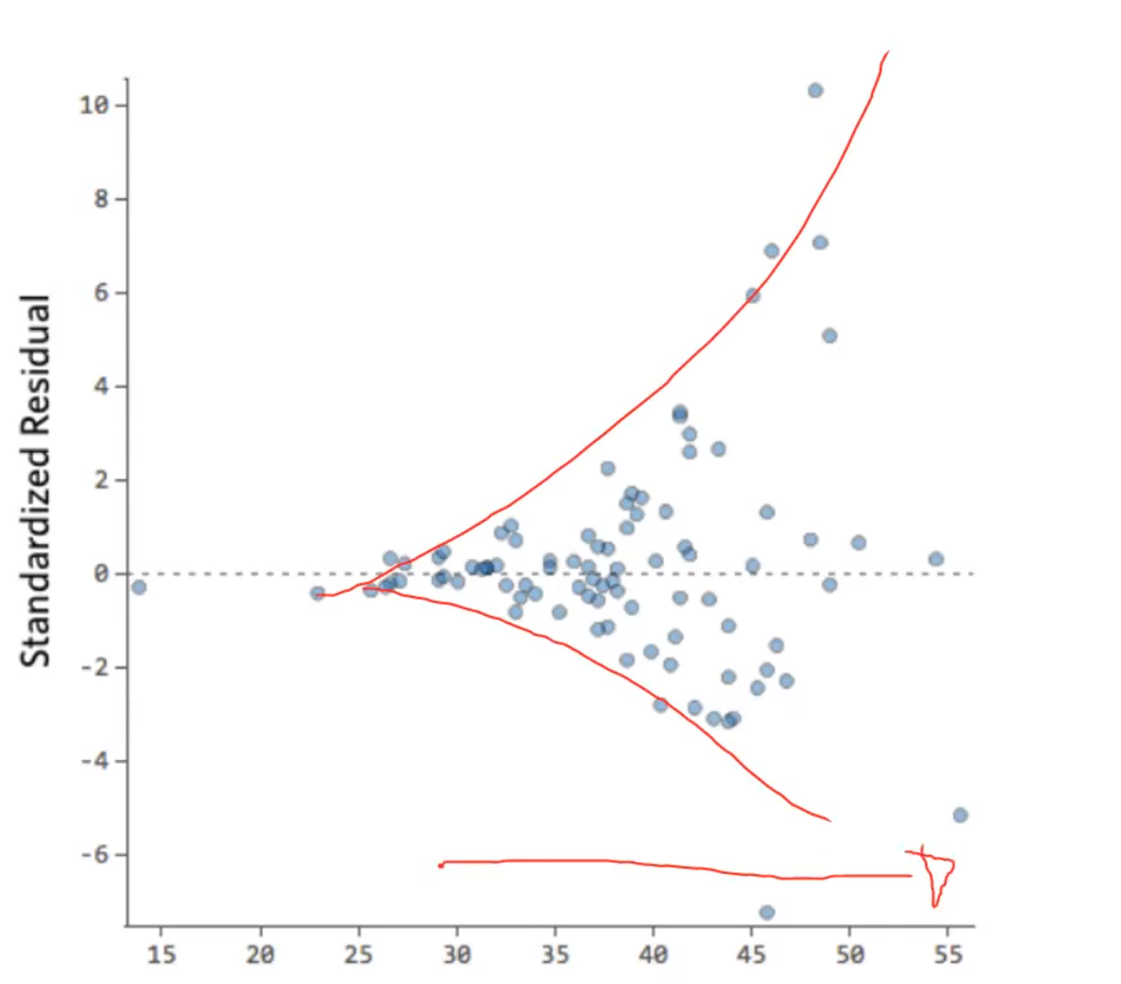

3.nolinear

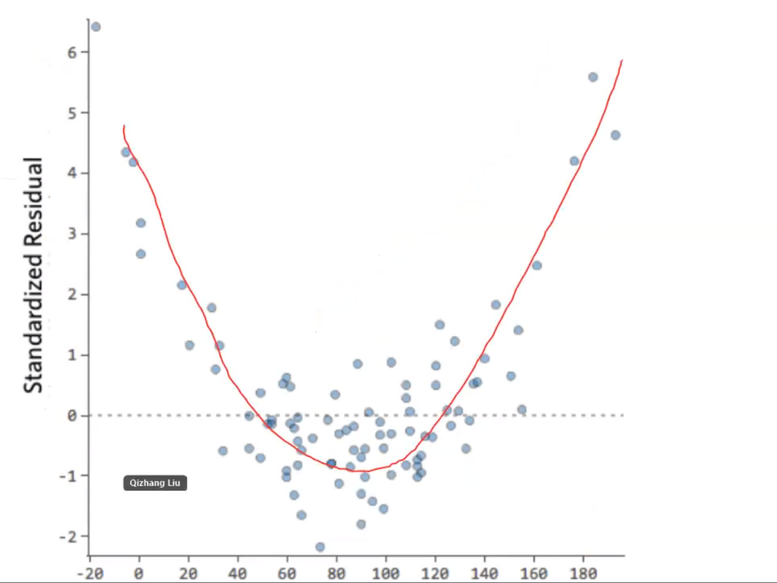

4.outliers

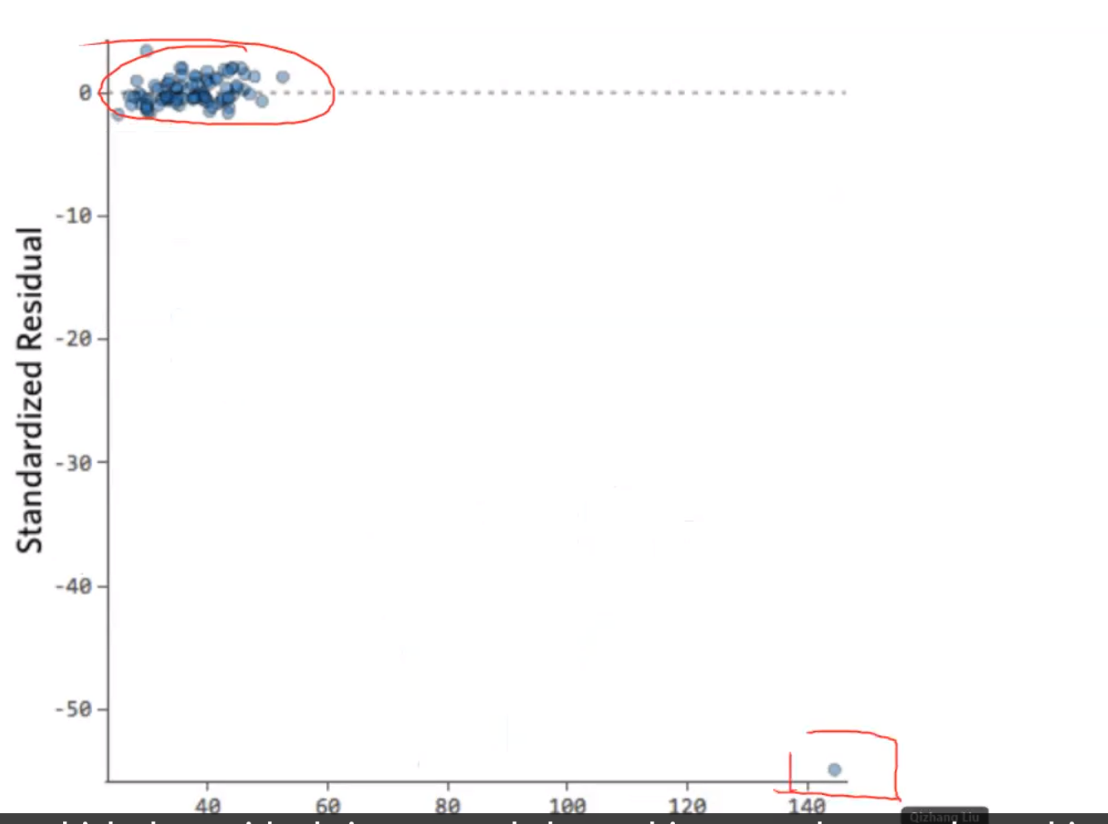

**增加R^2的方法**

1.bring more independent variables

2.remove outliers

3.cross validate to fine the model

4.break data in different groups

5.collect more data (avoid bias in data)

**多元线性回归**

model <- lm(overall**~.**, data=data) 有个点

summary(model)

**去掉某个variable**

model2 <- lm(overall~.**-weekend**, data=data)

summary(model2)

## 在判断是否要删去一个变量的时候

因为只要增加的variables，r一定会增加，不管增加的是什么variable！！

所以应该比较adjusted r-squared

**dummy variable**

把character变成numerical的时候，是按照字母排序的

weekday是level1，weekend是level2

这里weekendyes的Estimate的意义是，when all the other variable remain the same, those visiting during week**end** will have 0.71573 point lower feedback than those in weekdays. 永远是dummy variable和base value做对比。

如果有3个，divorced，single，married

建两个dummy variables虚拟变量， mar_married, mar_single

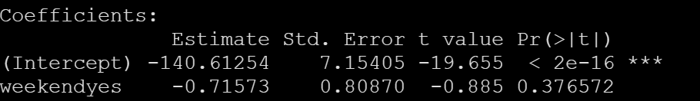

**Interaction effect**相互影响，**交互项**（有时一些变量单独是insignificant的，但和其他变量combine起来就significant了）

model <- lm(overall**~.**, data=data)

summary(model)

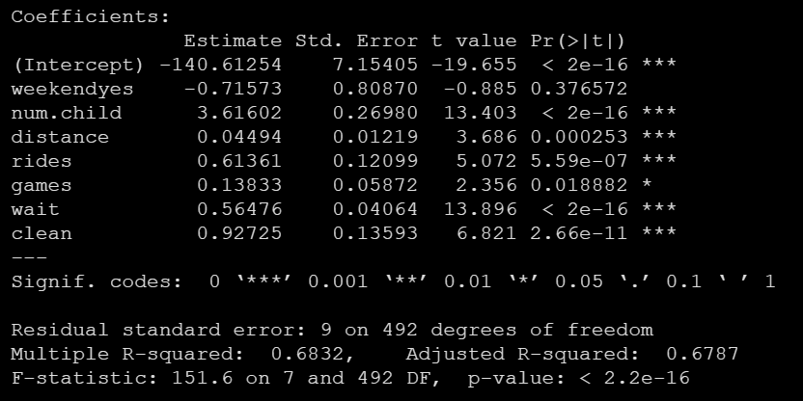

model3 <- lm(overall~.**+weekend*distance**,data=data)

summary(model3)

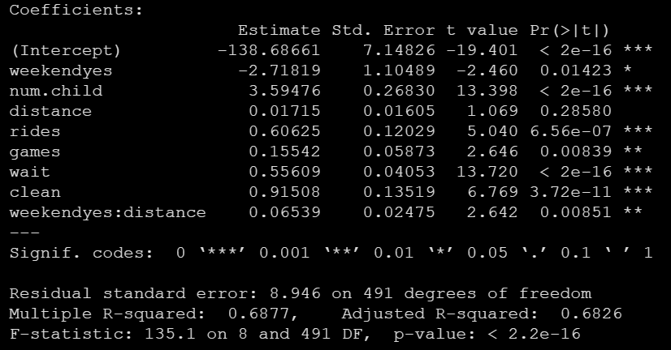

对比两个回归的结果

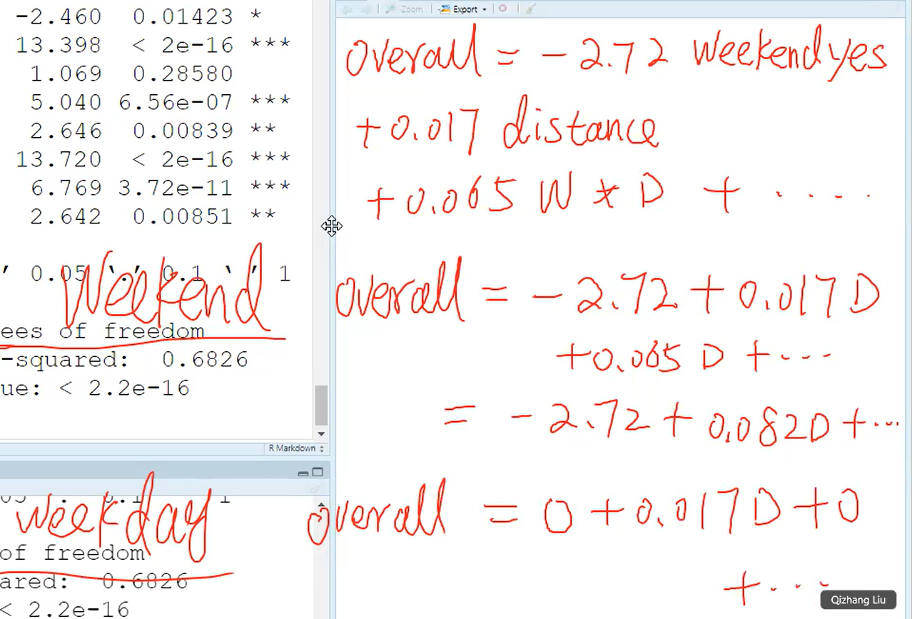

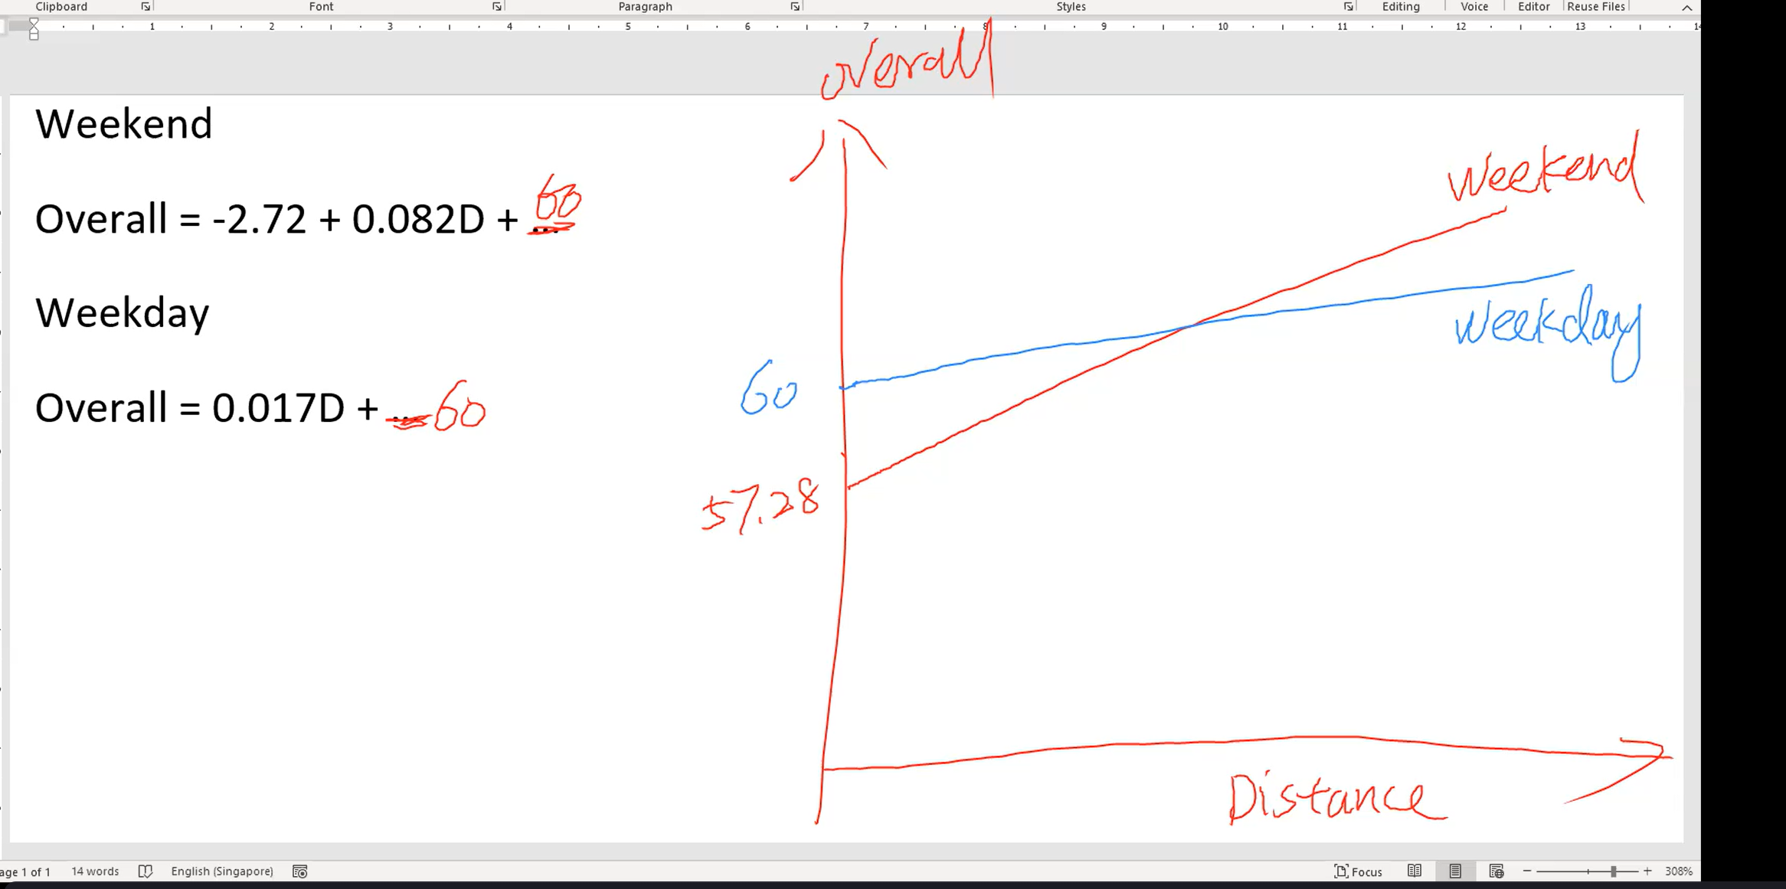

解释：

·1.weekend时distance对overall rating有更大的影响

2. live far way, the people have higher overall in weekend than in weekday

live near, people have lower overall in weekend than in weekday.

so for the marketer, should have different strategies according to their distance.

**非典型数字的数字处理（非numerical的处理）**

每增加一个小孩overall rate就会增加3.59476

assume the experience bring one child to no child is the same as the experience bring 2 to bring 1，并且认为bring2个孩子就是bring1个孩子的两倍

而事实上并不是这样

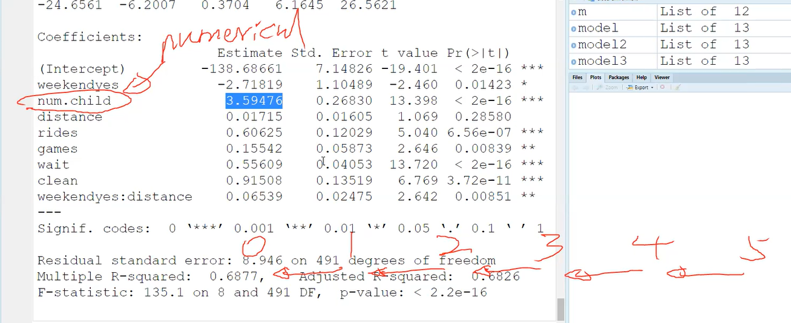

所以要convert into categories

1.可以变成factor

data$num.child <- as.factor(data$num.child)

model4 <- lm(overall~.+weekend*distance,data=data)

summary(model4)

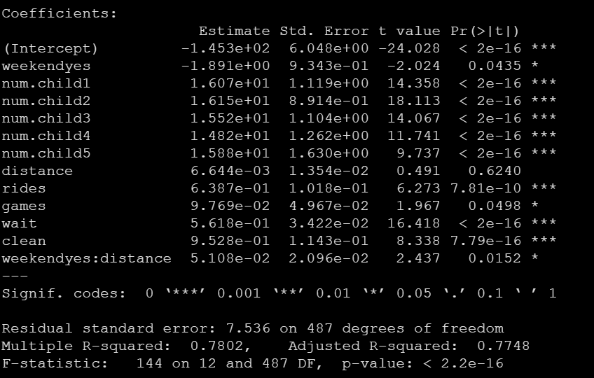

这样每个都和没有children比，有1个和没有比增加了1.67，有2个和没有比增加1.61

2.变成有children和没有children

data$has.child <- data$num.child != 0

data$num.child <- NULL

model5 <- lm(overall~.+weekend*distance,data=data)

summary(model5)

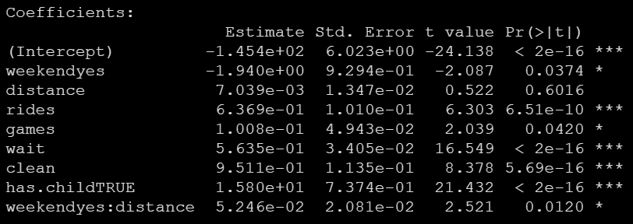

从上面的模型可以看出，有12345个小孩对于0个小孩的影响差不多，所以可以把他们笼统的变成有和没有小孩。

**External factors和internal factors的投入**

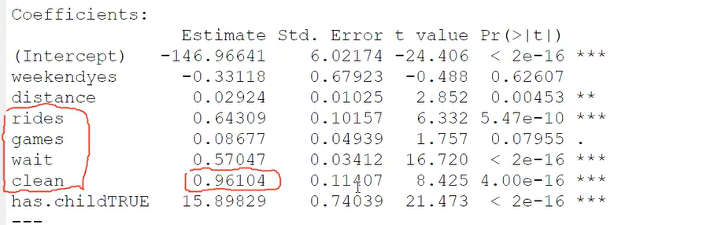

是否要在clean上投最多的钱？

考虑到clean的rate本来就很大了，所以增加同样的价钱，对clean提升的影响很小

­­­­­­­­­­­­­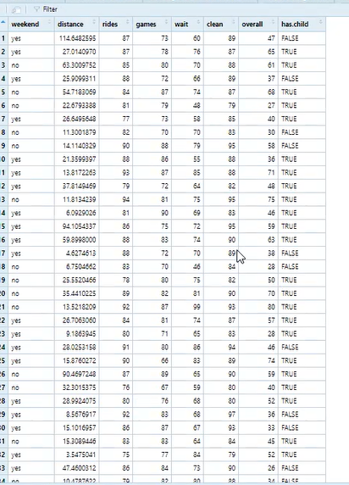

**所以需要Standardize/normalize the data**

因为**scale**不一样，所以会mislead conclusion(意思是clean的rate都是8090，而wait的rate都是6070)

所以应该standardize the data before the conclusion

data$rides <- scale(data$rides)

data$clean <- scale(data$clean)

data$games <- scale(data$games)

data$wait <- scale(data$wait)

model6 <- lm(overall**~.**, data=data)

summary(model6)

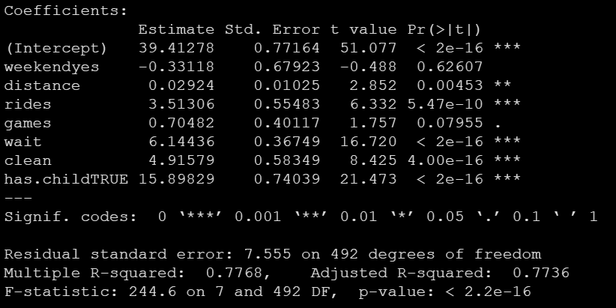

For every 1 standard increase in wait feedback, the overall feedback will increase by 6.14

应该投入到wait

**分析变量之间的相关性correlation**

cor(data.A[,2:31])



**可视化一些attributes的相关性**

library('PerformanceAnalytics')

chart.Correlation(data.A[,c('Top Rank','ROI','Top faculty','Intl Reputation','Research Reputation','Student Quality')],histogram=T,pch=19)

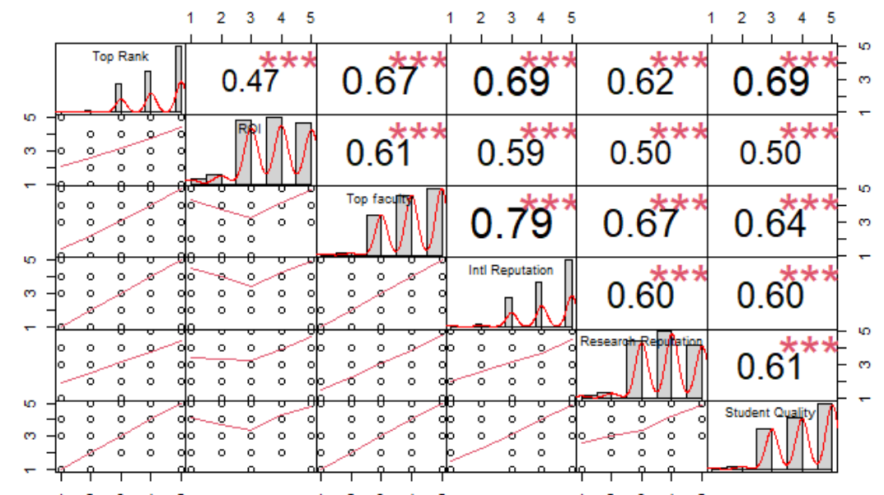

# Lesson9 PCA

**多重共线性multicollinearity**

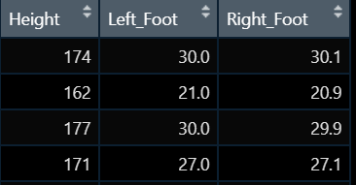

model2 <- lm(Height ~ ., data=d1)

summary(model2)

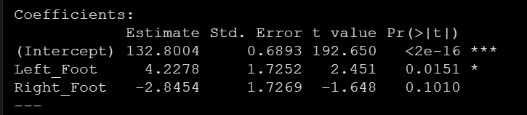

**为了解决多重共线性，采用dimensionality reduction降维- data extraction，就像用二维的相机图像记录三维的眼睛所看到的**

**主成分分析法 PCA model principle component explained** 这是unsupervised，没有manually give label，所以不知道pc1，pc2是什么，需要自己分析

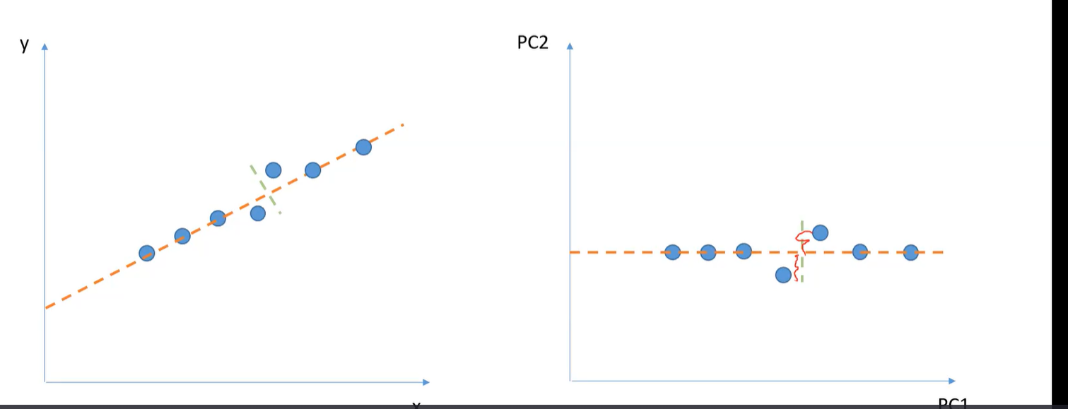



把几个新变量(pc1,pc2,…)写成原来变量（x1,x2,x3,…..）的linear combination的形式

data.s



brand.s <- prcomp(data.s)

biplot(brand.s)

第736个人，roi是neutral的，但给quality很低的分

但这个并没有研究价值，因为全是匿名的



**先scale，再取每个指标的平均值，再取8个变量**

data.sc <- data.A

data.sc[,2:31] <- scale(data.A[,2:31])

data.sc

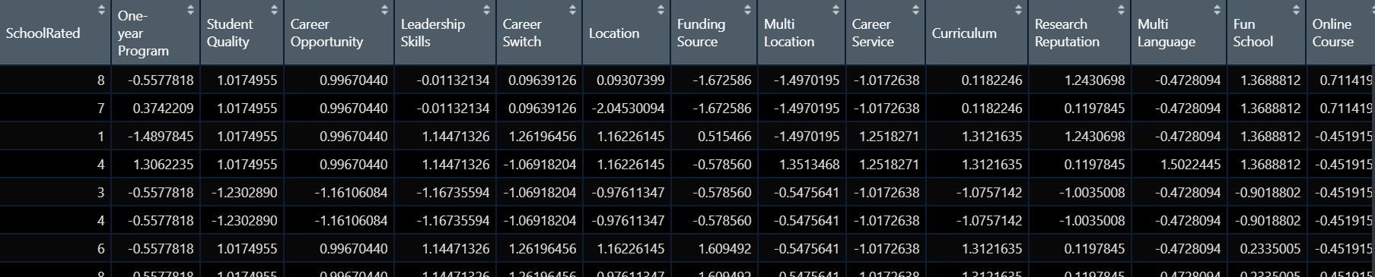

#去掉第一列

m.sc <- data.sc[,-1] %>% group_by(School) %>% summarise(across(everything(),mean)) %>% as.data.frame()

m.s <- m.sc[,c('School',attributes)]

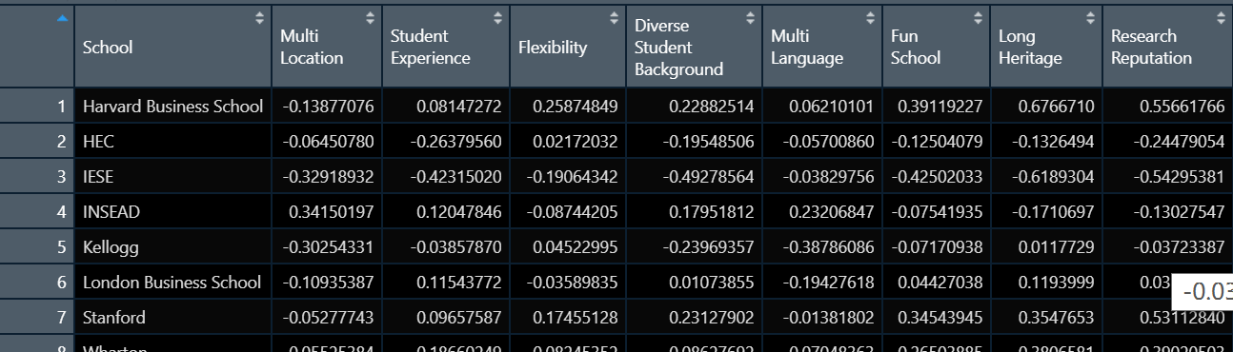

rownames(m.s) <- m.s[,1]

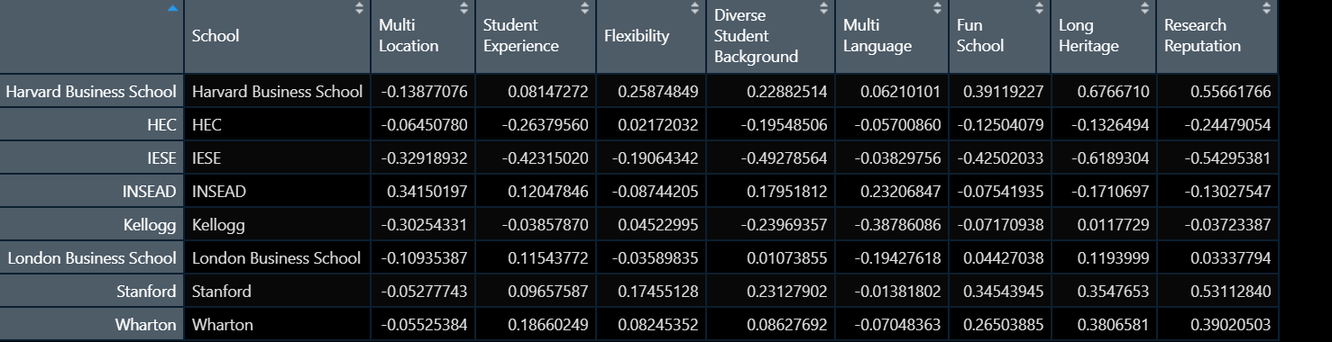

rating.pc <- **prcomp**(m.s[,2:9])

summary(rating.pc)



the first component explains 80.8% of the variance among the data and the first four components explain about 99% of the variance

plot(rating.pc,type="1")



plot用来解释performance of the parameter

horizontal number 1,2,3,4,5代表number of component we want to retain

一般用elbow的点作为削减到的dimension

biplot(rating.pc)

multi language和multi location和pc2几乎平行，所以外面把pc2命名为diversity

fun school，research reputation和pc1几乎平行，所以把pc1命名为reputation/quality

结合上面所说的，reputation/quality解释了80.8%的variance，所以是最important的因素，其次是diversity

Student view insead has neutral reputation/quality, but have high diversity

Kelloga has neutral reputation, but have low diversity

(并不一定越往右上越大，因为multi language是往下的，所以越往下越大)



# Lesson10 逻辑回归

**Logit regression**

去除某一列的回归

logitfit1 = glm(TARGET_B~ . **-holdout**, family="binomial", data = vetTrain)

summary(logitfit1)

**S shape 拟合曲线，画简单的logistic regression的smooth图**

library(ggplot2)

#变成factor的格式

data$choice <- as.factor(data$choice)

#加了一跳smooth的线

ggplot(data) + geom_point(aes(x=cartime,y=choice),position=position_jitter(width=0.1,height = 0.1)) + geom_smooth(aes(x=cartime,y=**as.numeric**(choice)))

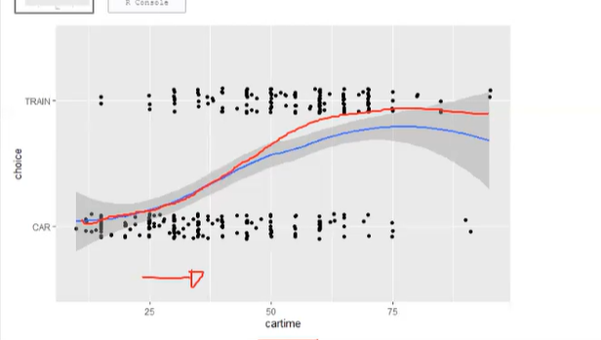



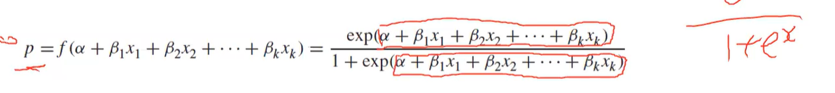

**linear和logistic的关联，在linear中预测y，而在logistic中预测p**

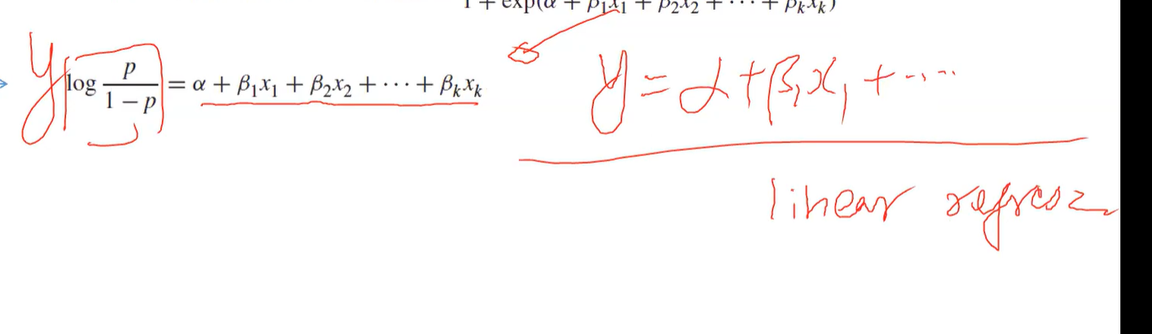**l**

**p/1-p means the ratio of success over ratio of failure**

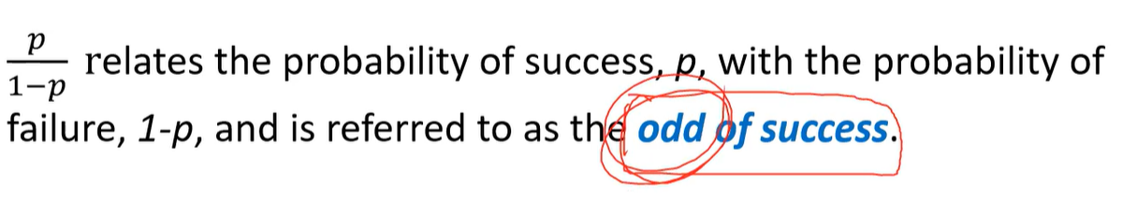

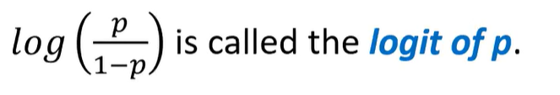

**所以从一种角度来说，logistic regression是用linear equation model to predict logit of p, once we can predict the logit of p, we can calculate p itself**

**预测千层面的例子**



triers$Person <- NULL

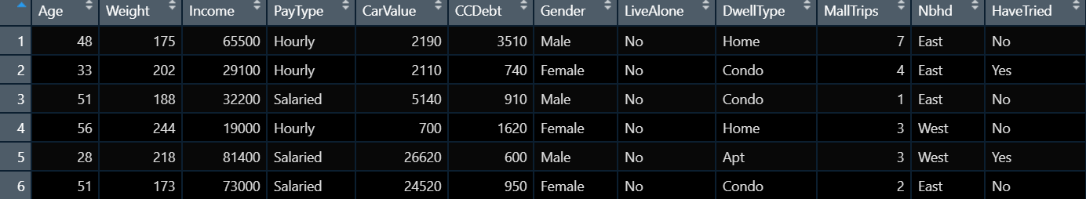

triers$HaveTried <- triers$HaveTried == "Yes" #变成true 和 false的形式

#Split data into training set and testing set一般在做modeling的时候都要有两个data set



set.seed(123) #这个是为了每次产生同样的random结果，123是标记的名称

**#随机取样 random把整个df分成两组，train和test**

sample <- **sample(**c(TRUE,FALSE),nrow(triers),prob = c(0.75,0.25),replace = TRUE)

#这里的nrow是指原dataframe的行数，一共有这么多行的true和false，比例是0.75和0.25；sample出来是一个vector

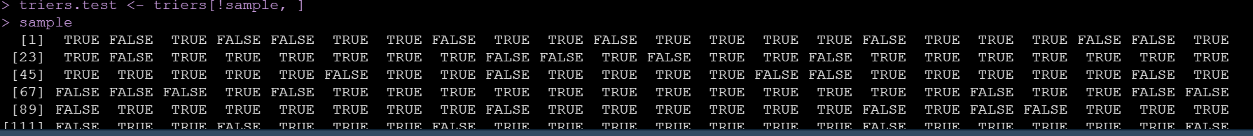

triers.train <- triers[sample, ]

triers.test <- triers[!sample, ]

**一、Naïve trial（整个部分不需要出现，仅仅是帮助理解）**

**1.关于Continous variable**

**第一步：画图，看趋势，才能确定是>threshold还是<threshold**

ggplot(triers)

geom_point(aes(x=Age,y=HaveTried),position=position_jitter(width=0.1,height = 0.1)) + geom_smooth(aes(x=Age,y=**as.numeric**(HaveTried)+1))

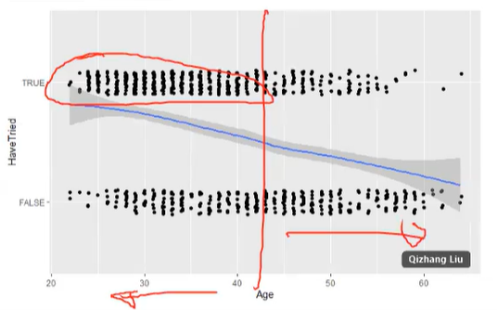

以下步骤仅为理解，不需要出现

所以我们简单地选取一个值，所有<这个值的都是我们的消费者

predict <- triers[,"Age"] < 35

predict <- factor(predict,levels=c("FALSE","TRUE"))



前面的predict是预测值，后面的actual是真实的值

table <- table(**predict** = predict, **actual** = triers[,"HaveTried"]) #前面是竖着，后面是横着

table

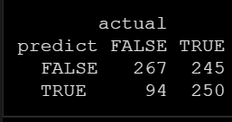

**#Error rate(misclassification rate)**

Overall, how often is the classifier wrong?

(table[1,2]+table[2,1])/sum(table)

**#Accuracy**

Overall, how often is the classifier correct?

(table[1,1]+table[2,2])/sum(table)

**这个table叫做confusion matrix，to compare the predicted yes and no with the actual yes and no**

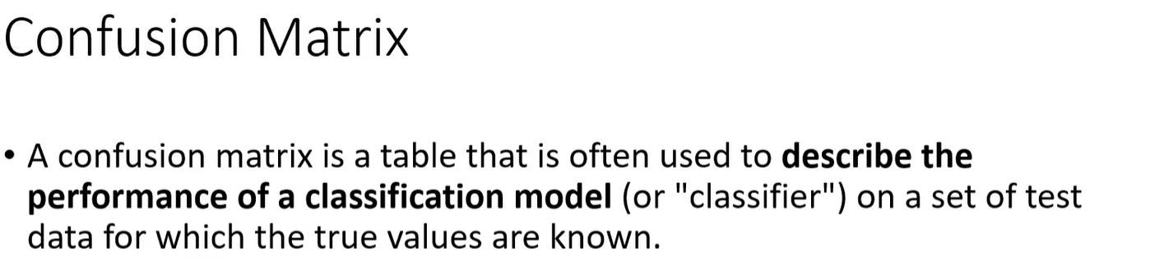

相关概念

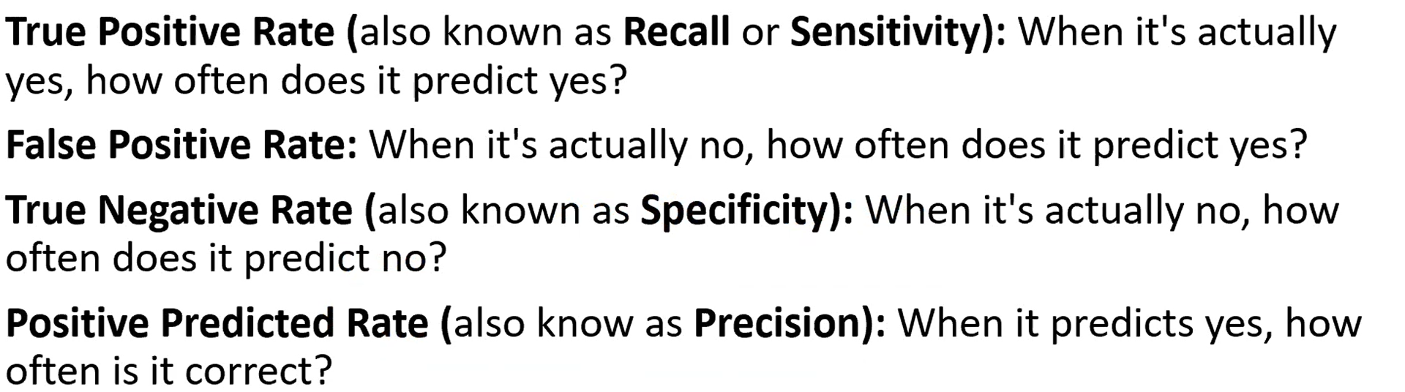

**第二步：写function来求最优的threshold，自动计算了error rate，就可以求得最小的**

PredictErrorByCutContinousVar <- function(threshold, data, predictor, outcome){

predict <- factor(data[,predictor] < threshold, levels=c("FALSE","TRUE"))

table <- table(predict = predict, actual = data[,outcome])

table

return ((table[1,2]+table[2,1])/sum(table))

}

**一个使用这个方程的例子**

> PredictErrorByCutContinousVar(35,triers,'Age','HaveTried')

[1] 0.396028

下面对所有在age范围内的数全部使用该方程

range(triers$Age)

ages<-23:64

errors <- sapply(ages,PredictErrorByCutContinousVar,triers,"Age","HaveTried")

建dataframe

df <- data.frame(Age=ages, Error=errors)

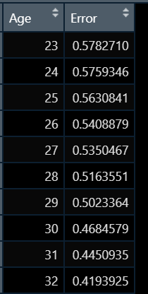

求出最佳的threhold

optimal.Age <- df[which.min(df$Error),"Age"]

画图

ggplot(df, aes(x=Age,y=Error)) + geom_line() + **geom_vline**(xintercept = optimal.Age, linetype="dotted",color = "red") + geom_text(aes(x=(optimal.Age+1), label=paste0("Optimal Cut-off Age: ",optimal.Age), y=0.45), colour="red", angle=90, text=element_text(size=11))

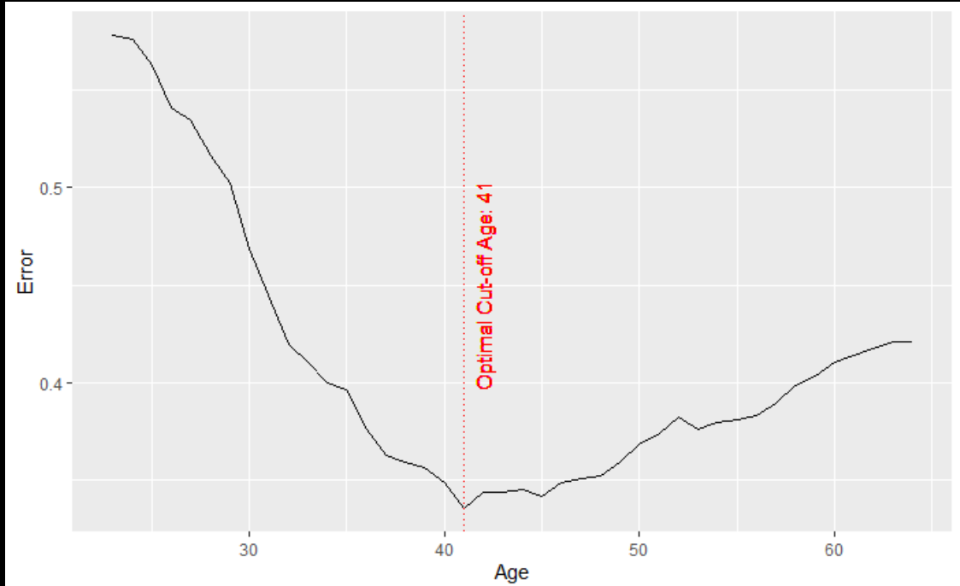

**2.关于Categorical Variable**

第一步：依旧是画图，查看关系

ggplot(triers,aes(x=PayType,fill=HaveTried)) + geom_bar(**position="fill"**, width = 0.5)

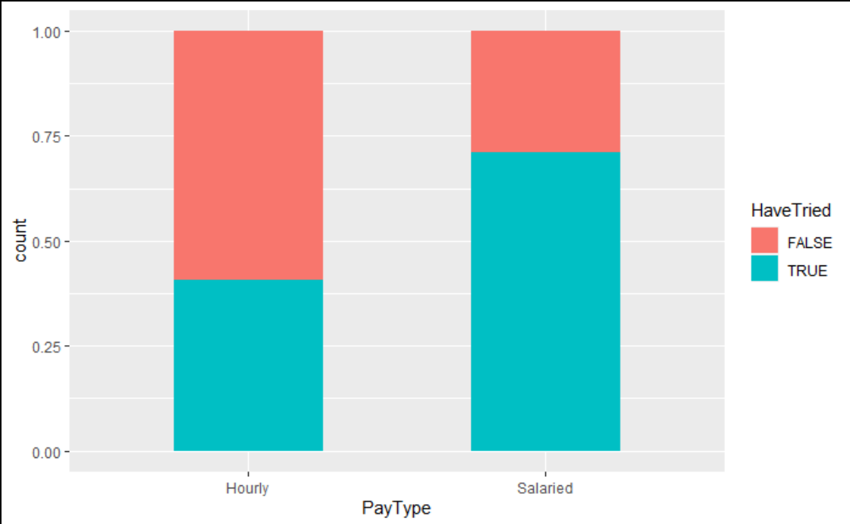

发现salaried的人更有可能buy

以下步骤仅为理解，不需要出现

所以我们简单地认为所有salaried的人都是我们的消费者

table <- table(triers$PayType == "Salaried", triers$HaveTried)

error <- (table[1,2]+table[2,1])/sum(table)

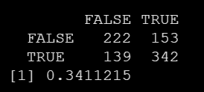

**二、logistic regression**

**fit.full** <- **glm**(HaveTried ~ ., data=**triers.train**, **family**=**binomial()**)

summary(fit.full)

# glm指generalized linear regression

# binomial指0和1的二项式回归

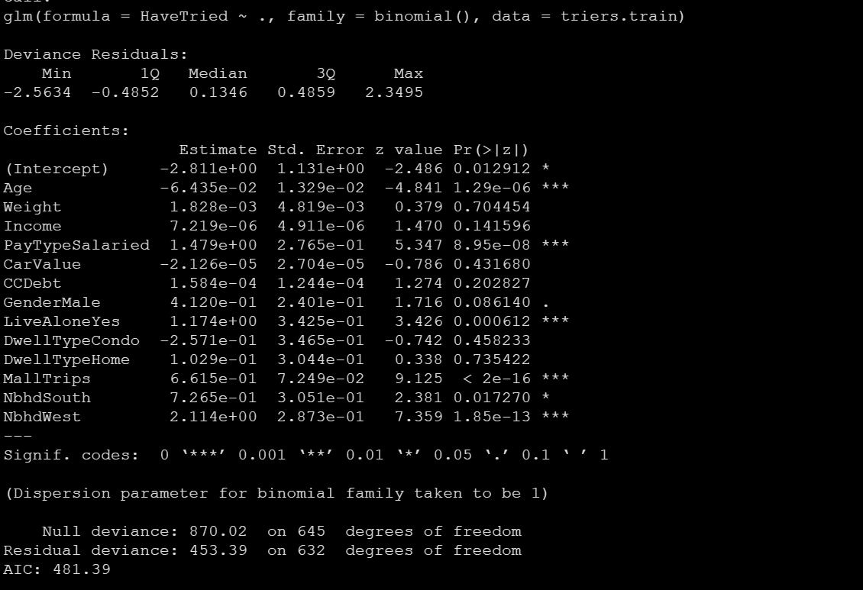

这里没有r squared了，只有AIC

AIC是akaike information criterion，越小越好

由于有很多insignificant的东西，所以要simplify，只保留significant的（**注意，这里只是一种方法，也并不一定是最好的，完全可以加入interaction factor来优化，需要具体情况具体对待**）

**fit.simplified** <- glm(HaveTried ~ Age + PayType + Gender +

LiveAlone + MallTrips + Nbhd, data=**triers.train**, family=binomial())

summary(fit.simplified)

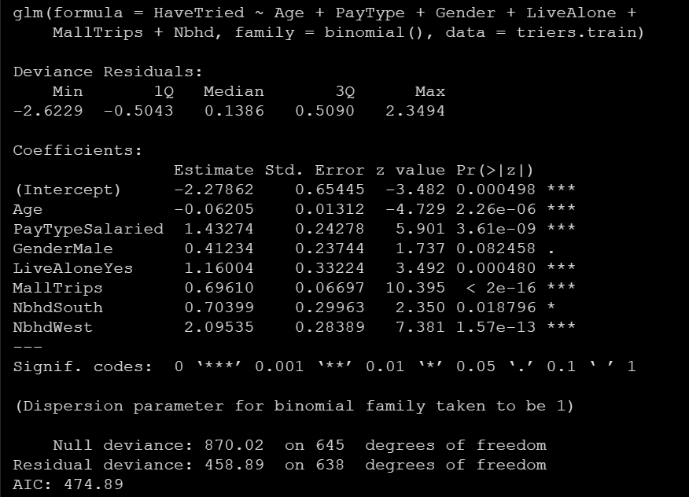

Age的系数是-0.06205，怎么**解释**：

Direct interpretation: If the person is one year older, **logit** will **decrease** by **0.06205**

相当于logit_new - logit_old = -0.06205

=log(odd_new) - log(odd_old)

=log(odd_new/odd_old)

odd_new/odd_old = e^-0.06205 = 0.94

**odd_new = 94% * odd_old**

Further interpretation: If the person is one year older, **odd of success** will **decrease** by 6%

**(1- e^-0.06205)**

同样对于Gender Male来说

e^0.412 = 1.51，所以**odd_male = 1.51 * odd_female**

the odd of success in **male customers** is 51% **higher** than the odd of success in **female customers**.

Like linear regression, for logistic regression, we not just use it as a **prediction model**, we also use it to understand what the impact of the **individual variable** on our final decision is. It will help us to make strategies rather than only take concrete action. If we only use it to do the prediction, we need to look at the **individual profile** of the customers, put the profile in our model, and then decide whether we should spend money on him/her. That is the **detailed action** you take for marketing. But sometimes we will not use this detailed action plan, we just want to have a high level of understanding of customers and **make marketing strategies**. For example, the strategy for different genders should be that we focus more on **males** than females.

Another thing we need to pay attention to is the **neighborhood**. We should not concentrate mainly on the west because if you take this as a regional based decision, we may **saturate** your market in the west, but you will lose your market in the east. So the right strategy for a company should be that you try to find **true reason** why the difference exists (maybe because the demographic profile of the people, more males or more salaried…), instead of only focusing on a group.

AIC变小了，也不能代表这个式子更好，因为变量变少了

所以要用anova test来验证

anova(**fit.simplified, fit.full**, test="Chisq") #简化的在前面

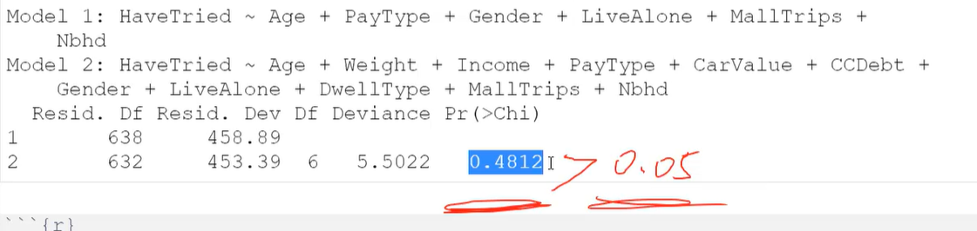

Pr**>**0/05，说明change/difference是insignificant，所以简化的没问题。

我们应该简化

**下面，我们要用这个求出来的模型fit.simplified来预测结果p**

对于简化之后的模型来说，就可以求得这样的公式，从而求得p

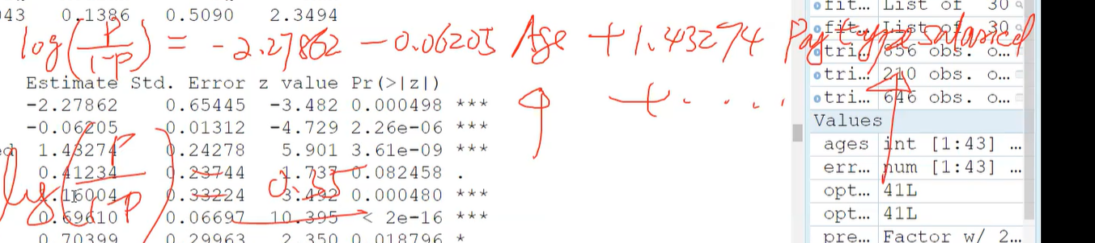

在r中的方法是，新建一列，叫做pred，这个就是我们要求的p

triers.train$**pred** <- predict(fit.simplified, **newdata = triers.train**, type=**"response"**)

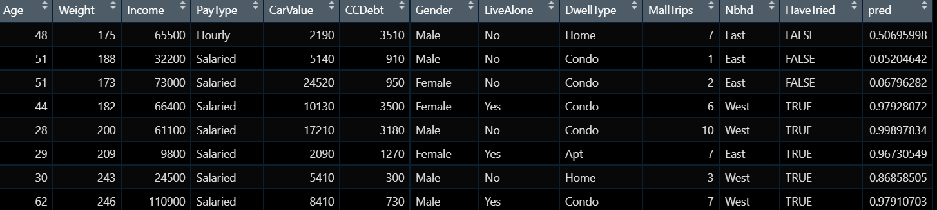

（如果没有type=’response’,求出来的就是logit而不是p） 这个只是帮助理解不需要出现

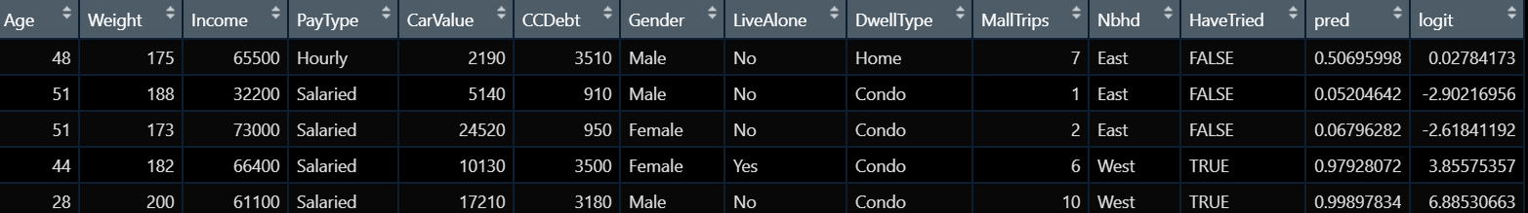

为什么没有r squared：

在linear regression中，我们可以轻松地measure the accuracy of prediction，因为我们measure的是difference between the predicted value and the actual value，即residual，并且try to minimize the residual, R squared is one measure to measure how the residual is minimized。

而在logistic regression中，我们想predict的是true or false（the direct outcome we want is true or false），但logistic regression只给我们probability，所以can’t tell what is the prediction, what is the accuracy, it very much depends on the threshold we choose.

**求出的p就是logistic regression predict的outcome**

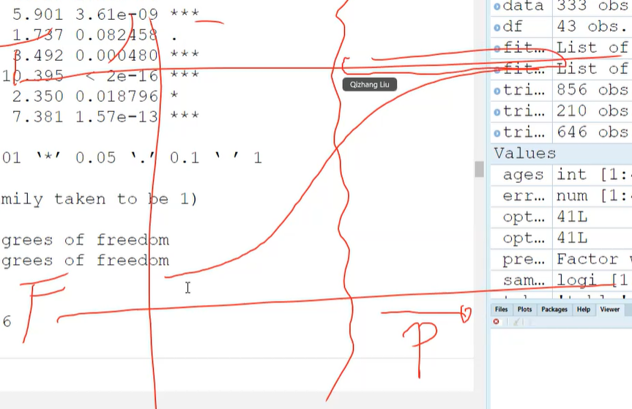

We choose the threshold, as long as the Predict probability is below this threshold, the outcome is False; if the predicted probability is above the threshold, then I predict the outcome is true. When the threshold changes, the accuracy changes.**所以logistic本身是不能给我们fitness的**

**下面是另外一种优化model的方法，加入interactive factor交叉变量**

fit.interactive <- glm(HaveTried ~ Age + PayType + Gender + Income + LiveAlone + MallTrips + Nbhd + **Income:LiveAlone**, data=triers.train, family=binomial())

summary(fit.interactive)

**但是我们可以通过其他方法取求出他的accuracy**

我们先假设当predicted probability大于**0.5**的时候，是true

triers.train$pred.outcome <- factor(ifelse(triers.train$pred >= 0.5,T,F),levels = c("FALSE","TRUE"))

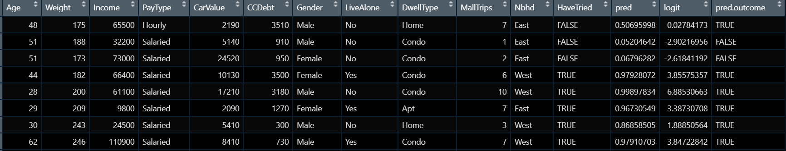

table <- table(triers.train$pred.outcome , triers.train$HaveTried)

errorrate <- (table[1,2] + table[2,1])/sum(table)

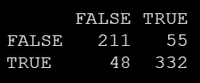



发现准确率还是不错的

下面，我们将这个model用于test set，来测试accuracy，方法和上面的一样

riers.test$pred <- predict(fit.simplified, **newdata = triers.test**, type="response")

triers.test$pred.outcome <- factor(ifelse(triers.test$pred >= 0.5,T,F),levels = c("FALSE","TRUE"))

table <- table(triers.test$pred.outcome , triers.test$HaveTried)

errorrate <- (table[1,2] + table[2,1])/sum(table)

errorrate

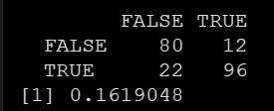

#发现training set和test set非常接近，这是好的，说明我们的model是consistent的

假设如果error rate of test set 远大于 error rate of training set, 说明**overfitting**.

可能的原因：

1.train too hard on the training set, we try to make our model as good as possible to predict the result on the training data, it leads to a result that our model is **customized/personalized** to the training data

2.bias in the training data selection, have your personalized favor in the training data. So it will not be applicable to the general data.

这里讲到一个例子，就是ai识别人脸技术，company use Chinese image to train the model, but when it comes to western people, it fails.

我们把这个p的预测值visualization一下（先用train的）

ggplot(**triers.train**, aes(x=pred, color=HaveTried, linetype=HaveTried)) + geom_density()

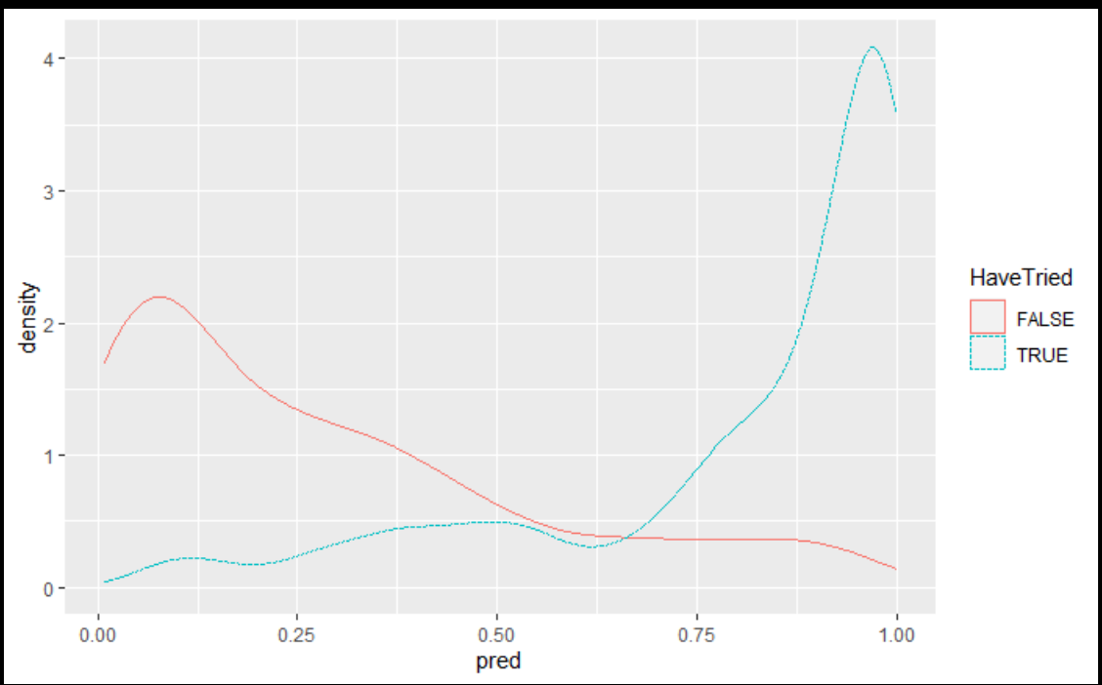

当p的值越大，true的人就越多。

**选取threshold的第一种方法：选取actual positive和actual negative的intersection**

对marketing的启示：

1.从这幅图中我们可以得知，who are more likely to buy the product; we should spend the money on these people who we think are potential customers

2.是否应该用error rate去 decide what threshold to use，一个accuracy更高的model更好吗？**不是的**

当我们计算error rate的时候，we treat predicted false & actual true和predicted true & actual false equally important, 但事实上他们并不play equally important role

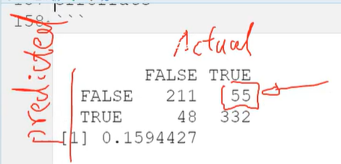

48这部分是**waste of money**。

55这部分是**lose opportunities**. If 55 becomes large, it means that we will miss out the true customers。我们使用这个model的结果，就只target on了我们认为true的人上面，而这部分人就miss 了，we will lose lots of opportunities. We are losing our potential customers to potential competitors.

一般来说，我们lose opportunity所带来的损失要大于waste money带来的损失

所以，instead of minimize the overall error rate, we should **put some leverage to the calculation**



譬如在前面加上*10和*1这样来区分他们的重要程度

**Precision & Recall**

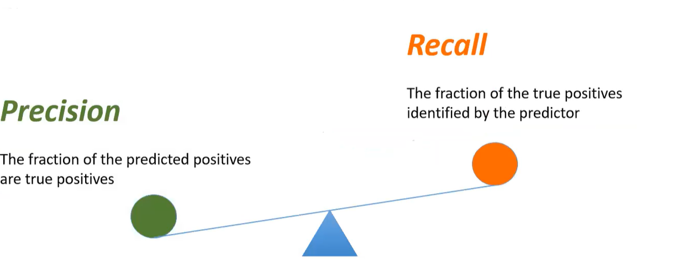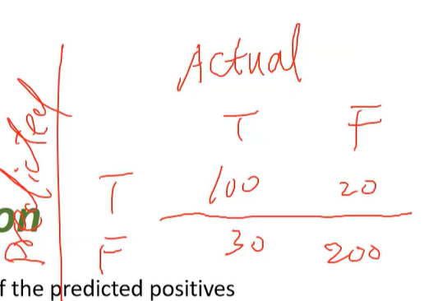

**Precision(positive predicted rate)**：true positive / predicted positive

The proportion of the true positive in the all the predicted positive

**When it is predicted positive, how often is it actually positive?**



If we only have small budget, we want a model with high **precision**. Because the person you target is very likely to become our true customer, every dollar we spend is effective. Precision indicates the **efficiency** in marketing.

**Recall(sensitivity/true positive rate)**: true positive / actual positive

The proportion of the true positive in the all the actual positive

**When it is actually positive, how often is it predicted positive?**



**Recall** represents the **coverage** of the true customers we can achieve.

**结论**

结合上面的图分析

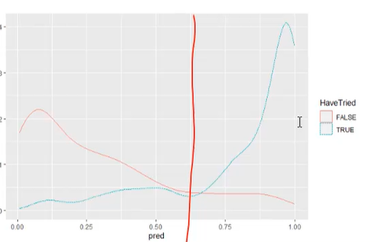

当我们选择的threshold increases，**precision** will **increase**; **recall** will **decrease;**

threshold decreases，**precision** will **decrease**; **recall** will **increase.**

我们可以通过计算出precison和recall来画图，进而验证该结论

#precision is the fraction of the predicted positives are **true positives**

precision <- function(threshold,model, data, field){

response <- predict(model,newdata = data,type="response")

prediction <- ifelse(response>threshold,T,F)

num.predicted.postive <- sum(prediction == T)

num.correct.positive <- sum(prediction == T & prediction == data[,field])

return (num.correct.positive/num.predicted.postive)

}

#recall is the fraction of the **true positives** the classifier finds

recall <- function(threshold,model, data, field){

response <- predict(model,newdata = data,type="response")

prediction <- ifelse(response>threshold,T,F)

num.predicted.postive <- sum(prediction == T & prediction == data[,field])

num.true.positive <- sum(data[,field] == T)

return (num.predicted.postive/num.true.positive)

}

Plot the precision vs. recall

plotPrecisionVSRecall <- function(model, data, field){

require(ggplot2)

thresholds <- seq(0,1,by=0.01)

precisions <- sapply(thresholds,precision,model,data,field)

recalls <- sapply(thresholds,recall,model,data,field)

df <- data.frame(Threshold=thresholds,Precision=precisions,Recall=recalls)

library(reshape2)

df1<-melt(df,id.vars="Threshold",variable.name="Type")

ggplot(data = df1,aes(x=Threshold, y=value, color=Type,lty = Type)) + geom_line()

}

完成公式，输入本例中的变量

plotPrecisionVSRecall(fit.simplified,triers.train,"HaveTried")

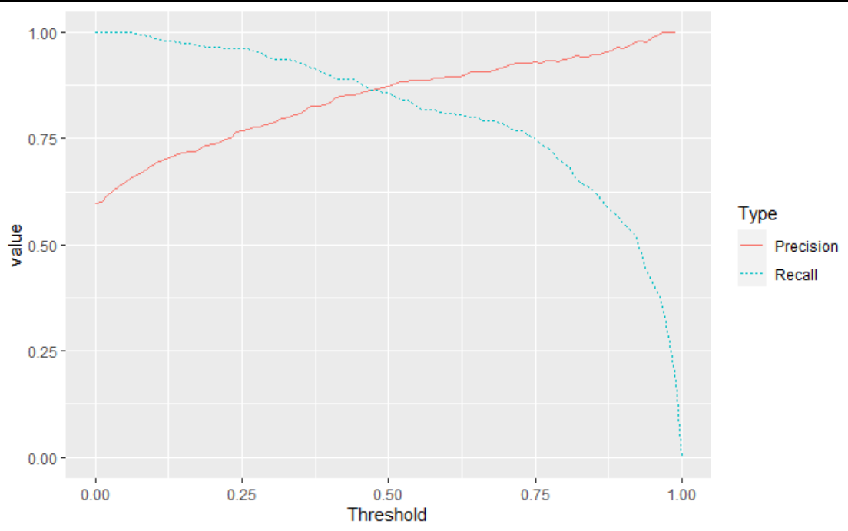

**选取threshold的第二种方法：选取precision和recall曲线的intersection**

**True positive rate & false positive rate**

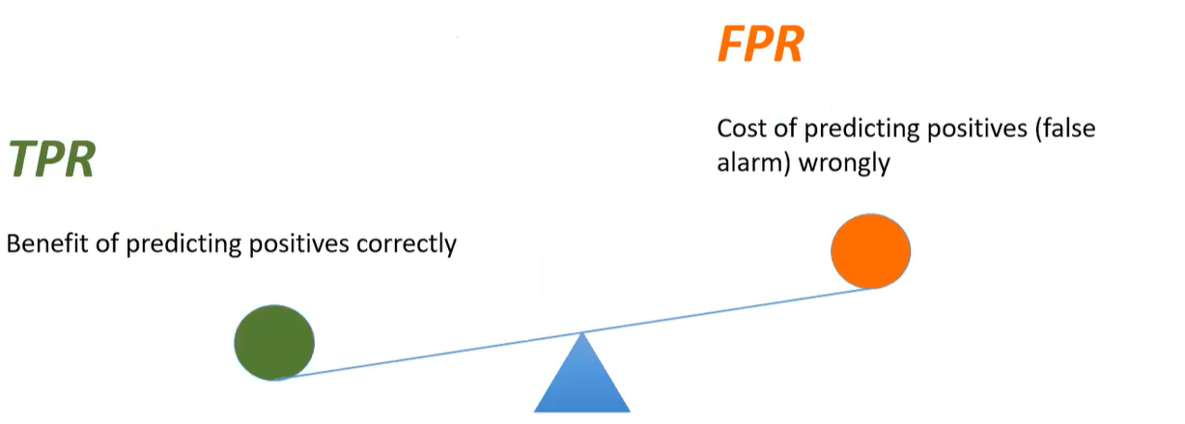

**TPR(recall)**

When it is actually positive, how often is it predicted positive?

**FPR**

When it is actually negative, how often is it predicted positive?

20/220

In covid 19 test, it means that people are wrongly diagnostic, it is very harmful and costly. Bring unnecessary mental pressure to people.

**同样，**我们可以通过计算出TPR和FPR来画图

TPR <- function(threshold,model, data, field){

#response <- predict(model,newdata = data,type="response")

#prediction <- ifelse(response>threshold,"Yes","No")

#TP <- sum(prediction == "Yes" & prediction == data[,field])

#P <- sum(data[,field] == "Yes")

response <- predict(model,newdata = data,type="response")

prediction <- factor(ifelse(response>threshold,"Yes","No"),levels=c("No","Yes"))

table<-table(prediction,data[,field])

return (table[2,2]/(table[1,2]+table[2,2]))

}

FPR <- function(threshold,model, data, field){

#response <- predict(model,newdata = data,type="response")

#prediction <- ifelse(response>threshold,"Yes","No")

#FP <- sum(prediction == "Yes" & prediction != data[,field])

#N <- sum(data[,field] == "No")

#return (FP/N)

response <- predict(model,newdata = data,type="response")

prediction <- factor(ifelse(response>threshold,"Yes","No"),levels=c("No","Yes"))

table<-table(prediction,data[,field])

return (table[2,1]/(table[1,1]+table[2,1]))

}

#This function is to plot the famous precision-recall curve.

plotROCCurve <- function(model, data, field){

require(ggplot2)

thresholds <- seq(0,1,by=0.01)

TPRs <- sapply(thresholds,TPR,model,data,field)

FPRs <- sapply(thresholds,FPR,model,data,field)

df <- data.frame(Threshold=thresholds,TPR=TPRs,FPR=FPRs)

ggplot(data = df,aes(x=FPR, y=TPR)) + geom_line()

}

plotROCCurve(fit.simplified,triers.train,"HaveTried")

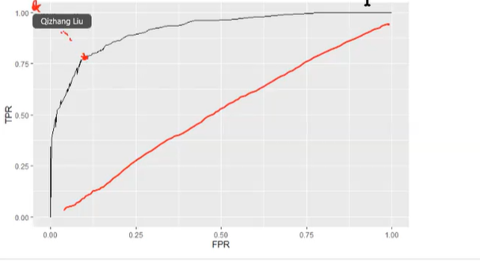

**选取threshold的第三种方法：选取TPR和FPR曲线（即ROC曲线）上closed to top left corner的那一点**

**通常会用在healthcare中**

# Lesson11 market basket analysis关联分析

尿布啤酒的案例：can we find some relationship among products that people may buy together

**Association rule**

Tell when people buy something, it is very likely that they also buy something.

TARGET的一个例子：

这个supermarket相信如果人们在某些关键阶段 **key transition periods**购买他们的产品，人们就会become their customers forever. 因为会留下special memory

如果一个lady同时购买了soap，detergent，zinc，calcium和handwashing fluid，她很可能怀孕了。Give her some coupon. It will not be a coupon especially for bay-care product, but will be pretended just like a normal coupon, but covers one or two bay-care products inside.

现在**every retailer is doing this！**

每一个物品叫做一个**item** 项

多个item叫做**item set** 项集 比如我们这里把sugar + milk看作一个item set

Rule是buy sugar+ milk，就一定会buy coffee powder

**Support** is an indication of how frequency the itemset appears in the dataset 支持度

4/6

**频繁项集**：支持度大于等于最小支持度min support阈值的项集



**Confidence** is an indication of how often the rule has been found to be true. 置信度

其实就是当你购买了A，有多大的可能也去购买B

3/4



**Higher confidence, better rule?**

It depends on **sample size**.

Maybe the rule is very **artificial**, it is just because the company have a promotion.

Maybe these products are very **popular** products. Large proportion of people whenever they visit the shops, they will buy these products. (比如说所有人来这个店都会buy duck，20%的人会顺便买豆腐，所以不能说买豆腐的一定会买duck)

所以我们引出了lift这个概念

**Lift** 提升度is the ratio of observed support to that **expected support if x and y were independent.** (x是item set，y是预测的也会买的东西)

商品A出现，对商品B出现提升的程度

Lift ({sugar, milk} , {coffee powder}) = 3/6 / (4/6*4/6) = 9/8

我们认为，the sale of sugar and milk will increase the sale of coffee powder



## 1.Aprior算法

**寻找频繁项集（支持度） + 筛选强关联规则（置信度）**

从频繁1项集，频繁2项集，频繁3项集……一直找到没得找为止（没有新的项集大于最小支持度



计算找出的所有频繁项集（频繁1项集，频繁2项集，频繁3项集……频繁k项集）里面的置信度，**永远是k-1项推出1项**，筛选所有置信度大于最小置信度的规则

 

流程：

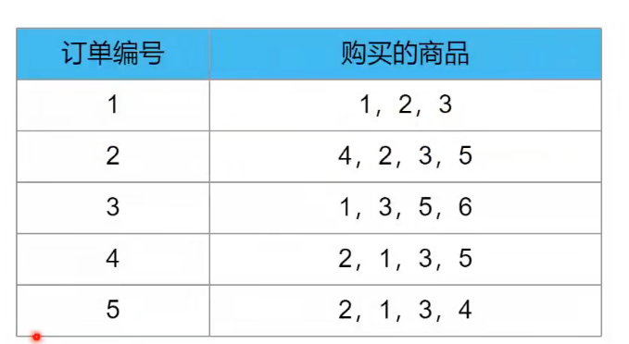

第一步：把4和6的item筛选掉，因为他们小于了最小支持度0.5。1235就是频繁项

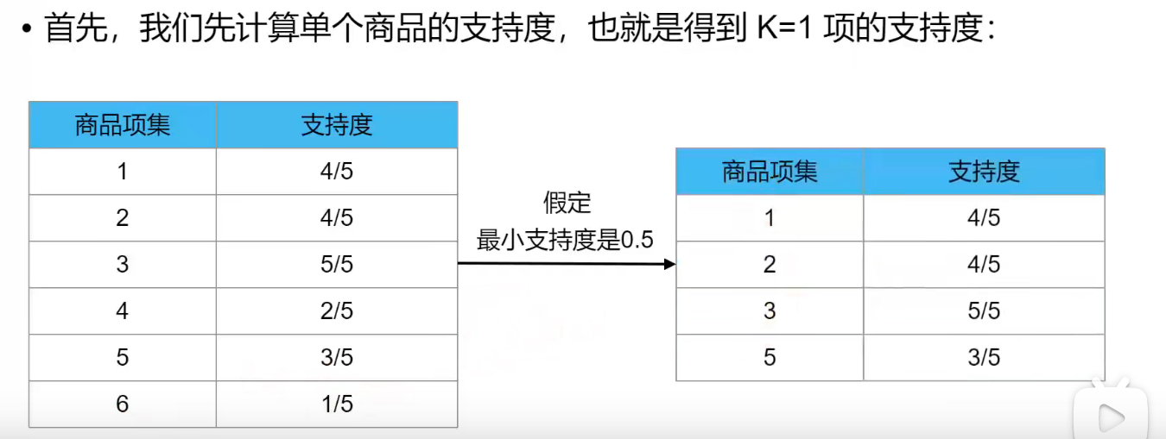

第二步：把剩下的4个两两组合，再进行筛选。（注意，此时看的还是原表）再把小于0.4的item set筛选掉，现在依旧还剩下1235**（又回到原来的item里面看）**

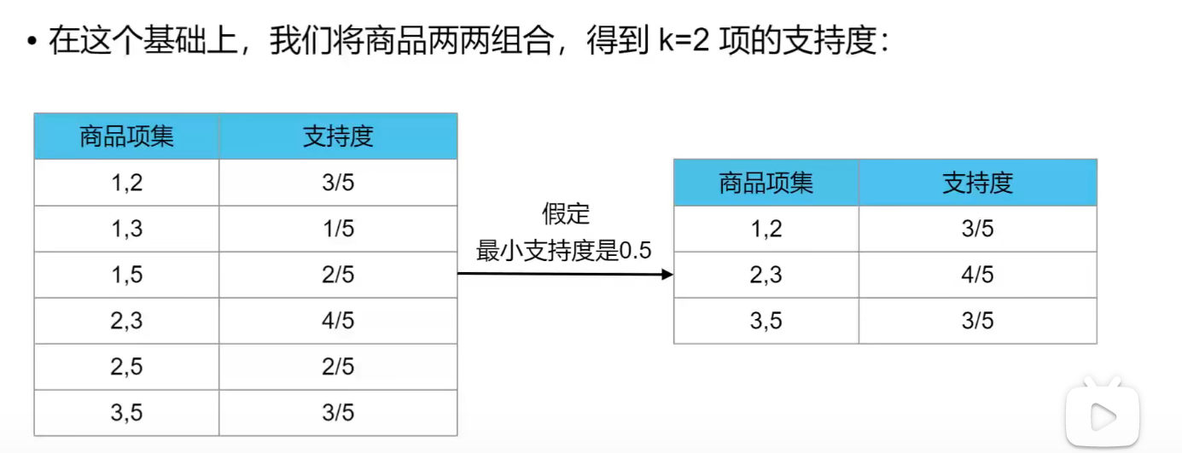

第三步：把剩下的4个三三组合，重复，只剩下123，没法四四组合了，所以就结束了

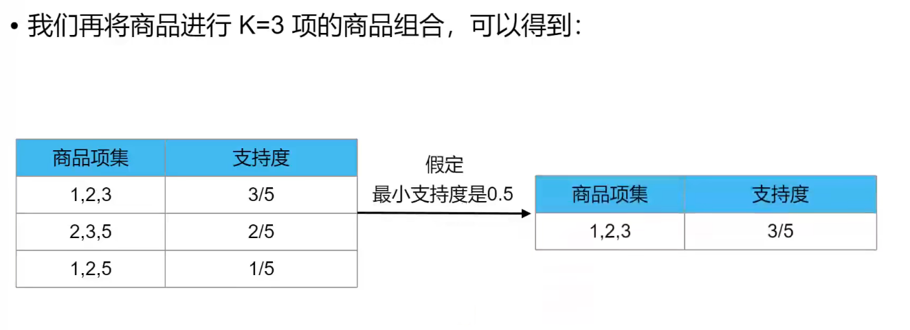



### 代码部分：

#这个包不考虑购买的先后顺序

from efficient_apriori import apriori

# 设置数据集

data = [['牛奶','面包','尿布'],

['可乐','面包', '尿布', '啤酒'],

['牛奶','尿布', '啤酒', '鸡蛋'],

['面包', '牛奶', '尿布', '啤酒'],

['面包', '牛奶', '尿布', '可乐']]

# 挖掘频繁项集合频繁规则 通过最小支持度和最小置信度去筛选

itemsets, rules = apriori(data, min_support=0.5, min_confidence=0.7)

print(itemsets)

print(rules)

所以我们这个结果解释起来就是

频繁1项集有：牛奶（出现4次），面包（出现4次），尿布（出现5次），啤酒（出现3次）

频繁2项集有：啤酒尿布（出现3次），尿布牛奶（出现4次），尿布面包（出现4次），牛奶



# 2. FP-grows 算法

取对数意味着原被解释变量对解释变量的弹性，即百分比的变化而不是数值的变化；  
目前，对于什么时候取对数还没有固定的规则，但是有一些经验法则：  
（1）与**市场价值**相关的，例如，**价格、销售额、工资**等都可以取对数；  
（2）以年度量的变量，如受**教育年限、工作经历**等通常**不取对数**；  
（3）比例变量，如失业率、参与率等，两者均可；  
（4）变量取值必须是非负数，如果包含0，则可以对y取对数ln(1+y);  
取对数的一个缺陷就是难以预测原变量的值。因为对数模型中预测的是lny,而不是y.

**画图的例子汇总**

**1.求两个变量之间的关系：先求density，再画图 点图**

cs$deadline <- as.Date(cs$deadline)

cs$launched <- as.Date(cs$launched)

cs$duration <- as.numeric(cs$deadline - cs$launched)

cs <- cs[cs$launched > as.Date('2000-01-01'),]

#求这两个因素的关系，先求density，看看哪个log10之后能normal

ggplot(cs,aes(x=duration)) + geom_density()

ggplot(cs,aes(x=usd_pledged_real)) + geom_density()

ggplot(cs,aes(x=log10(usd_pledged_real))) + geom_density()

#所以要scale_y_log10()

ggplot(data=cs,aes(x=duration, y=usd_pledged_real)) + geom_point(alpha=0.1) + geom_smooth(color='blue') + scale_y_log10()

**2.求不同类别的，3个变量之间的关系：一般都是color=category，size是第3个变量 点图**

分析的时候说：y比较大的类别，y大的原因；y比较小的类别，y小的原因。

Analysing the two charts, it seems that Dance and Theater has higher rate of success due to larger average amount pledged per donor as well as large number of backers, as well as generally a smaller, more achievable goal. Comics has a high success rate mainly due to large number of backers and smaller goal. Technology usually has a large goal and relatively small number of backers, thus it is more likely to fail its fundraising target.

library(ggrepel)

df2 <- cs %>% group_by(main_category) %>% summarise(success_rate=sum(state=='successful')/n(),

mean_pledge=mean(ppb),

median_goal=median(usd_goal_real))

ggplot(df2,aes(x=mean_pledge,y=success_rate,color=main_category,size=median_goal))+

geom_point()+

geom_label_repel(aes(label = main_category), size=2.5,box.padding=0.3)+

xlab('Average Amount Pledged per Backer (USD) ') +

ylab('Success Rate')

**3.在2上面扩展，又增加了2个变量。相当于探索4个x和y之间的关系。这时候画两个图。 点图**

cs$apg <- cs$ppb/cs$usd_goal_real

df2 <- cs %>% group_by(main_category) %>% summarise(median_backers=median(backers),median_goal_contribution=median(apg))

ggplot(df2,aes(x=median_goal_contribution,y=success_rate,color=main_category,size=median_backers))+

geom_point()+

geom_label_repel(aes(label = main_category), size=2.5,box.padding=0.3)+

xlab('Average Percentage of Goal Contributed per Backer') +

ylab('Success Rate')

**4.求按照时间的变化 横坐标是时间 折线图**

plot a line chart to show how the overall average monthly amount pledged varied

df1$launched <- as.Date(paste0(**format(**as.Date(df1$launched), "%Y-%m"**)**,'-01'))

ggplot(data=df1) + geom_line(aes(x=launched,y=usd_pledged_real),stat='summary',fun.y='median') +

xlab('Launched date') +

ylab('Monthly median Amount Pledged')

**5.比较不同种类，某个指标的平均值 柱状图**

cs$ppb <- ifelse(cs$backers>0,cs$usd_pledged_real/cs$backers,0)

#总的average

a <- mean(cs$ppb)

#在bar的形式下，先将y变量求和，再用mean显示

#再加一条平均线

ggplot(data=cs,aes(x=reorder(main_category,ppb),y=ppb)) + geom_bar(stat = 'summary', fun.y = 'mean') + theme(axis.text.x=element_text(angle=90)) + geom_hline(yintercept=a,colour = 'blue', size = 0.7) + labs(y='Average amount pledged per backer', x='Category')

**6.普通的比较不同种类 某个变量的区别 点图 加boxplot**

ggplot(data=cs,aes(x=main_category,y=usd_goal_real)) + geom_point() + geom_boxplot(color='black') + coord_cartesian(ylim = c(0,60000)) + theme(axis.text.x=element_text(angle=90))

7.展现两个指标的某个数量各有多少 **柱状图**

df <- p %>% group_by(SUBJECT_RACE, TIME.SCENARIO) %>% summarise(number_of_cases=n(),.groups = 'drop')

ggplot(data=df,aes(x=SUBJECT_RACE,y=number_of_cases,fill=TIME.SCENARIO)) + geom_bar(stat='identity',position='dodge')

country_coord[(rownames(country_coord)==c('Portugal')) | (rownames(country_coord)==c('United Kingdom')) | (rownames(country_coord)==c('France')) | (rownames(country_coord)==c('Spain')) | (rownames(country_coord)==c('Germany'))]